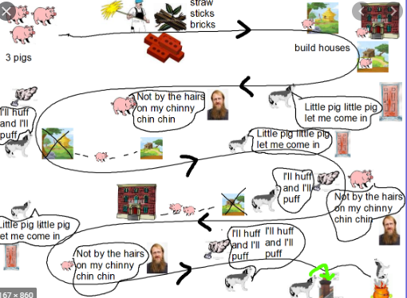
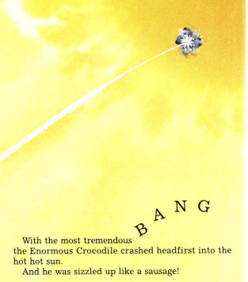
Year 3 Reading Week 2. Day 4.
Text: The Enormous Crocodile
If you have the book, make sure you have read up to end of the book.

Reading focus: Sequence
(Identify the main ideas drawn from more than one paragraph and summarise these)
- Think about the events in the story in chronological (time) order.
- Draw a small picture and short caption to summarise each main part of the narrative (story).
- Use these to create a story map- you can cut and stick them or set them out directly onto the page.
Example of what a story map could look like:

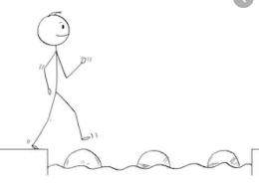
Year 3 Reading
Steppingstone activity
Day 4
Reading Focus: Sequence
If you have the book, make sure you have read up to end of the book with an adult or older sibling.

Reading focus: Sequence
(Identify the main ideas drawn from more than one paragraph and summarise these)
- Think about the events in the story in order.
- Think about the beginning, middle and end.
- Use these ideas to create a simple story map- you can cut and stick them or set them out directly onto the page.
- Write a caption under each picture.
Example of what a story map could look like:
