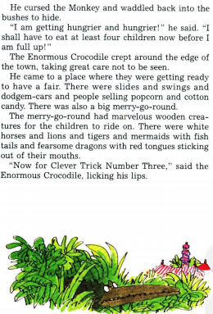
Year 3 Reading
Text: The Enormous Crocodile
If you have the book, make sure you have read up to end of P 36 (“Now for clever trick number three,” said the Enormous Crocodile licking his lips.)
.

Reading focus: Inference
Find and record the words from the text that give evidence for the following statements:
- The Enormous crocodile felt angry towards the monkey when his clever trick number two failed.
- The children were all happy that there was a seesaw in the playground.
- The crocodile was very crafty.
Write one more statement of your own and copy out the evidence that you have to justify that statement.

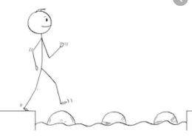
Year 3 Reading
Steppingstone activity
Day 2
Reading Focus: Inference

Text: The Enormous Crocodile
If you have the book, make sure you have shared the book up to page 36 to match up with where we are in writing activities.

Draw a picture of the Enormous Crocodile with a speech bubble coming out of his mouth to tell how he is feeling at this point in the story and why.
Choose another character and draw that one with a speech bubble coming out of its mouth to tell how it is feeling and why.

