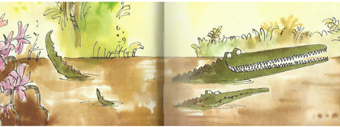
Year 3 Writing
Week 2
Lesson 3
LO: To vary sentence starters
Task:
If you have the book, make sure you have read up to end of P 44 (That’s not a bench….he wants to eat you all up.)
There are many different ways of starting sentences. If you start by saying where, when or how something happened, it is called a fronted adverbial.
When you start a sentence this way, you need to use a comma before you go on to explain the action.
E.g. Last week, the Enormous Crocodile tried to catch children for his dinner.
Use the fronted adverbials (in the table) to begin your own sentences linked to the story.
Adverbial of time | Adverbial of place | Adverbial of manner
Later that day, | In the river, | With a wicked grin,
The day before, | On the merry go round, | With a shriek of fright,
The last time they met, | Up in the tree, | Laughing excitedly,

Success Criteria:
1. Choose a fronted adverbial from the table to start a sentence.
2. Separate the fronted adverbial from the rest of the sentence with a comma.
3. Include the normal range of punctuation in your sentences.
4. Re-read to check the sentences make sense.
5. Try to create sentences with two ideas joined by a conjunction.
6. Start each sentence on a new line.
E.g. On the merry go round, there was danger lurking but the children were too excited to notice.

Extra challenge (optional):
Write a few extra sentences that use fronted adverbials that you have thought of yourself.

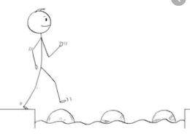
Year 3 Writing
Steppingstone activity
Lesson 3
LO: To use different sentence starters.
Task:
Share the book with an adult or older sibling up to end of P 36 (“Now for clever trick number two,” said the Enormous Crocodile licking his lips.)
If all your sentences start in the same way it can get very boring to read.
Read the sentence starters.
Copy the different sentence starters but finish them off with your own ideas. Try to remember to put a comma.
- On the river, there was a…..
- Each day, the Enormous Crocodile……
- On the merry go round, the…….
- Up in the tree, there was….

Success Criteria:
- Copy the sentence starter.
- Finish the sentence with your own idea.
- Check your sentence make sense.
- Include correct capital letters/full-stops.
- Start each new sentence on a new line.
Example
On the river, there was a dangerous crocodile scaring all the animals.
Extra challenge (optional):
Write some sentences that use your own ideas for different ways to start.

