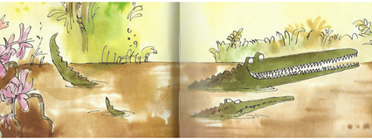
Year 3 Writing
Lesson 5
LO: To use a variety of sentence types in my imaginative writing
Task:
Think about what has happened throughout the story. Do you think that the crocodile got what he deserved in the end?
Choose a character you feel you understand well. Think about what it did and how it felt. You are going to pretend to be that character and write a diary entry in role.
You can choose one event to describe and recount in detail or describe a few events from the book.
Try to avoid writing all the same sentence structures each time. For example, try to use a question, an exclamation and start the sentences in lots of different ways. Remember to use pronouns (it, them, they, he, she etc.) to avoid repetition of same nouns.
You should be aiming to write about a page of lined A4 (the size of a page of school English book)
Success Criteria:
- Write about events in past tense.
- Write in the first person (I, me, we etc.).
- Make sure you include adverbs to describe verbs and adjectives to describe nouns.
- Group ideas together in paragraphs.
- Use correct basic punctuation and try to use a variety of sentence types, word order and sentence starters to avoid boring repetition.
- Join two ideas in a sentence with conjunctions.
Example:
Dear Diary,
What a day!
I woke up this morning to the sounds of the jungle. As I opened my eyes, I could hear the chattering of the cheeky monkeys, the trumpeting of the wise elephants and the crashing and tramping of the fat, round hippos. Just another normal day. I thought to myself, I couldn’t wait to see my friend Mary and go and play in the park after school today…..
Extra challenge (optional):
Try to include at least one fronted adverbial to say where, when or how things happened in your diary entry.

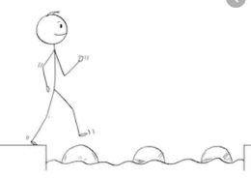
Year 3 Writing
Steppingstone activity
Lesson 5
LO: To use clear sentences in my creative writing.
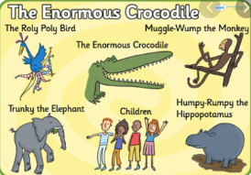
Task:
Choose a character you liked from the book.

Think about what the character did and how it felt.
Draw a picture of the character.
Write at least 4 sentences to say what happened and how your character felt. Write the events in order of when they happened. You can pretend you are writing it in a diary.
Make sure you write in order of events and join two ideas with a conjunction.
Success Criteria:
- Write sentences in the past tense.
- Write sentences in the first person (I, me, we etc.)
- Try to include adjectives to describe nouns.
- Try to include adverbs to describe verbs.
- Include correct, basic sentence punctuation (capitals/full-stops).

Example:
Dear Diary,
I had a scary day today and nearly got eaten by a crocodile! I went to play in the park with my friend Mary…….

