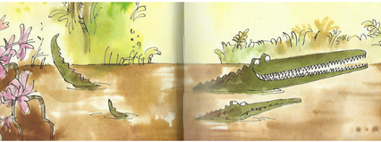
Year 3 Writing
Week 2
Lesson 2
LO: To use and spell words with common endings
Task:
Read up to end of P 36 (“Now for clever trick number three,” said the Enormous Crocodile licking his lips.)
Answer these questions in your head: What did the Enormous Crocodile do? Who saved the children this time?
These are common endings that you need to know how to spell- they do not have necessarily have a root word so are slightly different to suffixes.
The Y3 endings you are finding today are: -sion, -sure, -ture.
1. Sort the words given into a table with headings -sion, -sure, -ture.
2. Try to find three extra words of your own to put in each column.
3. Practise spelling these words (using: ‘look, say, cover, write, check’ method)
division | treasure | adventure | decision | creature
measure | invasion | pleasure | collision | television
picture | nature | confusion | enclosure | furniture

Success Criteria:
Look, say, cover, write, check is a method of learning spelling, where children:
- Study a word.
- Say it aloud a few times.
- Cover it up with a piece of paper or their hand.
- Write the spelling next to the original word.
- Check their version to see if they got it right

Example
-sion | -sure | -ture

Extra challenge (optional):
Use some of the words with endings that you listed in sentences to practise their spellings and show you understand their meanings in context. Make the sentences link to the story of the Enormous Crocodile.

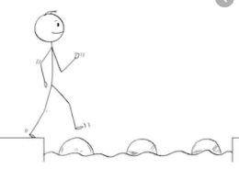
Year 3 Writing
Steppingstone activity
Lesson 2
LO: To spell and use suffix -es after a word ending in y
Task:
Share the book with an adult or older sibling up to end of P 36 (“Now for clever trick number two,” said the Enormous Crocodile licking his lips.)
Answer these questions: What did the Enormous Crocodile do? Who saved the children this time?
A suffix is an ending you add to a root word to slightly change its meaning.
We are going to look at suffix -es after a word ending in y.
You change the y into an i and then add the suffix.
spy +es = spies
- Make a table of how these words ending in y are spelt when you add the suffix -es.
- Try to find three extra words of your own to put in each column.
- Practise spelling these words (using: ‘look, say, cover, write, check’ method)
fly | try | reply | copy
baby | carry | hurry | cry

Example
Root word | + es
fly | flies
Success Criteria:
Look, say, cover, write, check is a method of learning spelling, where children:
- Study a word.
- Say it aloud a few times.
- Cover it up with a piece of paper or their hand.
- Write the spelling next to the original word.
- Check their version to see if they got it right

Extra challenge (optional):
Write some sentences that use some of your words from the suffix table to show their meanings.

