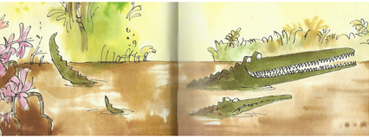
Year 3 Writing
Week 2
Lesson 4
LO: To use conjunctions to extend sentences.
Task:
If you have the book, make sure you have read up to the end of the story.
A clause is an idea or piece of information contained in a sentence. More than one clause in a sentence sometimes needs to be linked with a conjunction to extend the sentence. Sometimes it needs a pronoun to avoid repetition of same words.
Single clauses: The crocodile was enormous. All of the animals were scared of the crocodile.
The crocodile was enormous so all the animals were scared of him.
(1st clause) (conjunction) (2nd clause) (pronoun)
Look at the conjunctions in the table.
Choose some of the conjunctions from the table to use within sentences about the characters or events in the book.
when | then | since
so | although | while
if | therefore | meanwhile
because | after | unless
Make sure you understand the meaning of each conjunction you use.
Success Criteria:
1. Choose a conjunction from the table to join two ideas within a sentence.
2. Include the normal range of punctuation in your sentences.
3. Re-read to check the sentences make sense.
4. Start each sentence on a new line.
5. You can use different conjunctions of your own choice if it makes more sense.
E.g. The Enormous Crocodile was trying to catch children although the other animals were trying to protect them.

Extra challenge (optional):
Try to include a fronted adverbial at the start of some of your sentences.
E.g. In the park, the Enormous Crocodile was trying to catch children but meanwhile the other animals were trying to protect them.
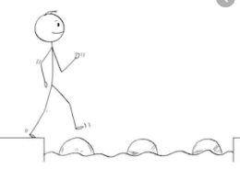
Year 3 Writing
Steppingstone activity
Lesson 4
LO: To join ideas within a sentence
Task:
Share the book with an adult or older sibling up to end. What do you think of what Trunky did to the crocodile? Do you think he deserved it? Was it a good ending?
If all your sentences are always short they can get very boring to read.
Read the short sentences.
Join the pairs of short sentences to make longer sentences joined with a word from the table.
and | for | but
or | so | when
if | but | because

The crocodile was mean. It was very greedy.
The children liked playing in the park. They were in danger of being caught for dinner.
A Roly-Poly bird was in the trees. It watched the crocodile from up high.
An elephant threw the crocodile into space. It was fed up of all the nasty tricks.
Success Criteria:
- Read the pairs of sentences.
- Join the red and black parts with a word from the table.
- Check your sentence make sense.
- Include correct capital letters/full-stops.
- Start each new sentence on a new line.
Example
The crocodile was mean because it was very greedy.
Extra challenge (optional):
Write some sentences that use your own ideas and words but are joined by words from the table.

