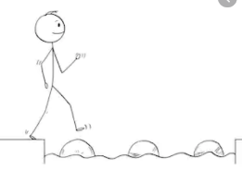
Year 4 Maths
Steppingstone activity
Lesson 10
LO: To divide 2 digits by 1digit
Success Criteria:
- Read the calculation carefully. How many are you dividing by? This is called the divisor.
- Divide the tens digit by the divisor
- Divide the ones digit by the divisor
- Add the answers together. This is the answer to the original calculation.

Model
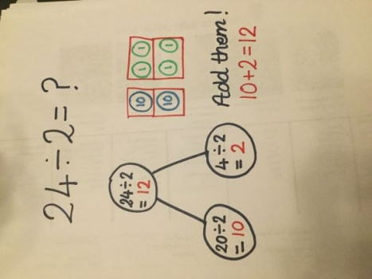
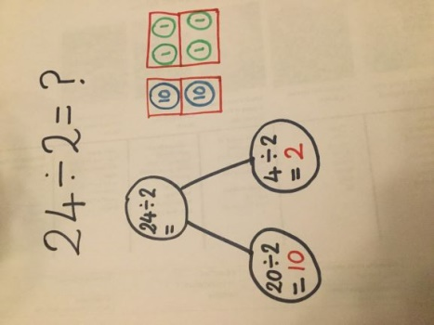
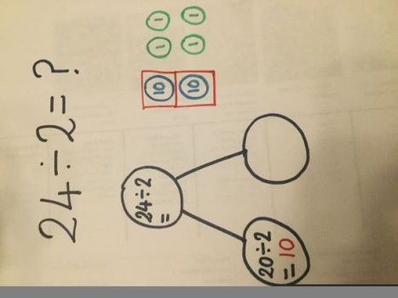
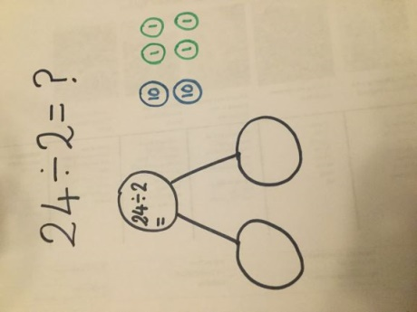
- 2. 3. 4.

Now you try…
28 ÷ 2 = 14 36 ÷ 3 = 12 44 ÷ 4 = 11

Year 4 Maths
Year 4 Maths
Main activity
Complete at least 2 columns, more if you can!
Task 1 | Task 2 | Task 3 | Task 4
Practice  Complete the part-whole models.  44 ÷ 3 = 14 r2  56 ÷ 5 = 11 r1  86 ÷ 4 = 22 r2  87 ÷ 4 = 22 r3 | Practice  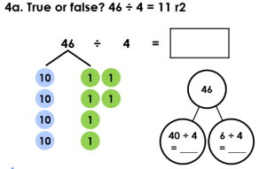  True part-whole model: 40 ÷ 4 = 10, 6 ÷ 4 = 1 r2  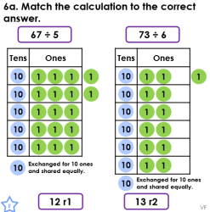  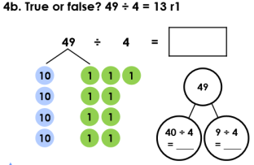  False, 49 ÷ 4 = 12 r1 part-whole model: 40 ÷ 4 = 10, 9 ÷ 4 = 2 r1  67 ÷ 5 = 13 r2; 73 ÷ 6 = 12 r1 | Reasoning  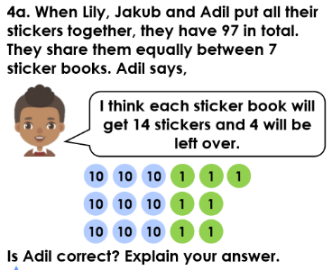  Adil is incorrect because if you share 97 between 7 people, each person would get 13 and there would be a remainder of 6.  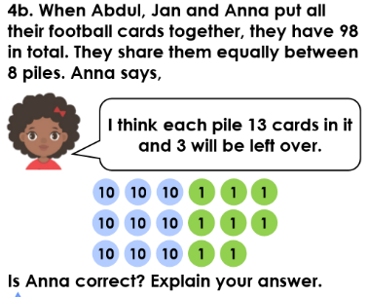  Anna is incorrect because she does not have enough football cards for everyone to receive 12; 98 ÷ 8 = 12 r2. | Problem solving  