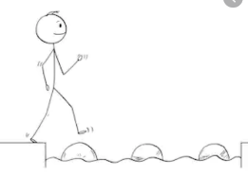
Year 4 Maths
Steppingstone activity
Lesson 10
LO: To divide 2 digits by 1digit
Success Criteria:
- Read the calculation carefully. How many are you dividing by? This is called the divisor.
- Divide the tens digit by the divisor
- Divide the ones digit by the divisor
- Add the answers together. This is the answer to the original calculation.

Model
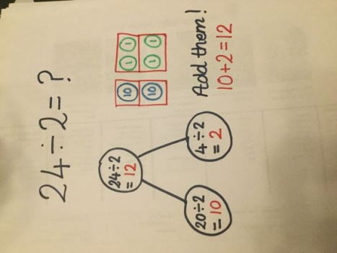
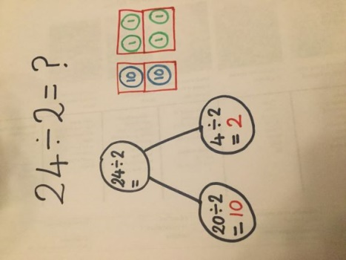
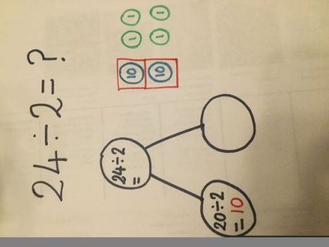
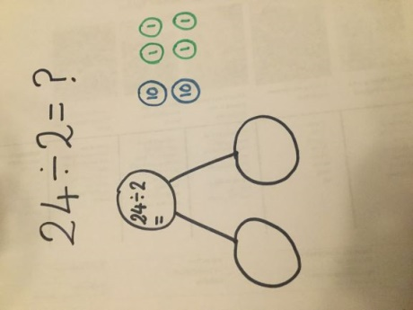
- 2. 3. 4.

Now you try…
28 ÷ 2 = 36 ÷ 3 = 44 ÷ 4 =

Year 4 Maths
Lesson 10
LO: To divide 2 digits by 1 digit
Task:
You are going to practise dividing! You will be identifying remainders.
Success Criteria:
- Draw the part-whole model.
- Partition the dividend (number you are dividing) and solve the first calculation – use your knowledge of times tables
- Solve the second calculation - use your knowledge of times tables
- How many are left over?
- Add the answers together and put the remainder on the end.

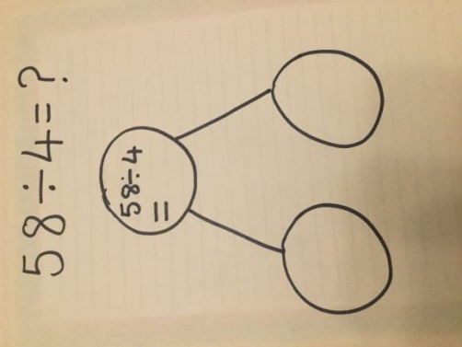
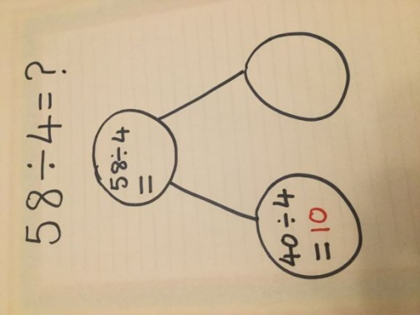
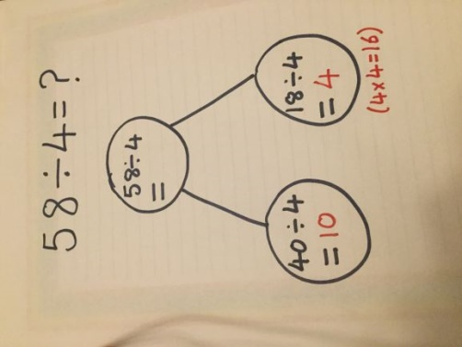
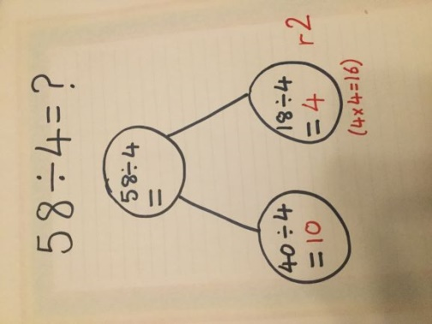
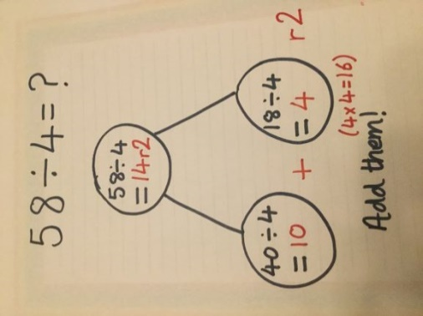
Model:
- 2. 3. 4. 5.

Year 4 Maths
Main activity
Complete at least 2 columns, more if you can!
Task 1 | Task 2 | Task 3 | Task 4
Practice  Complete the part-whole models.  44 ÷ 3 =  56 ÷ 5 =  86 ÷ 4 =  87 ÷ 4 = | 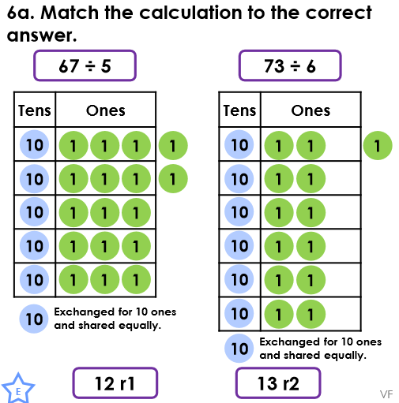  Practice  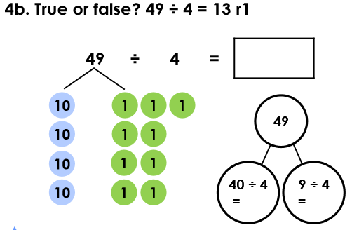  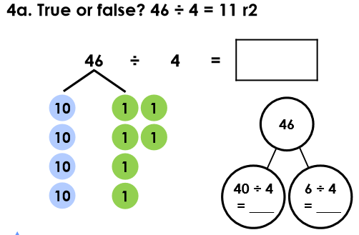 | Reasoning  Explain your answers.  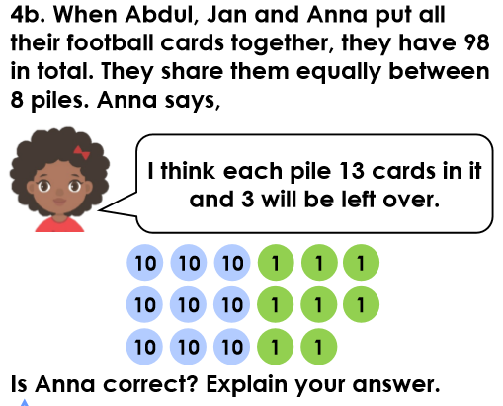  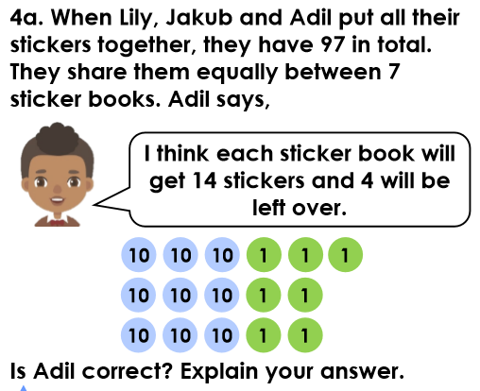 | Problem solving  