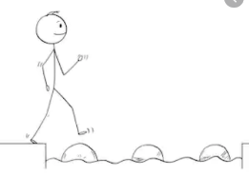
Year 4 Maths
Steppingstone activity
Lesson 6
LO: To multiply 2 digit numbers by 1 digit
Success Criteria:
- Draw your part/whole model
- Multiply the tens x ones
- Multiply the ones x ones
- Add them together

Model
- 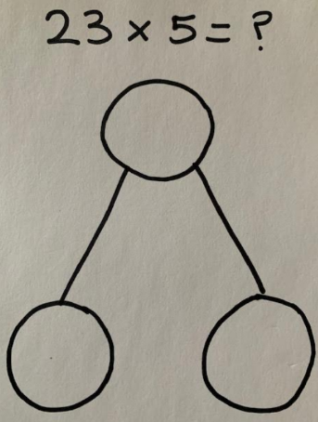 2. 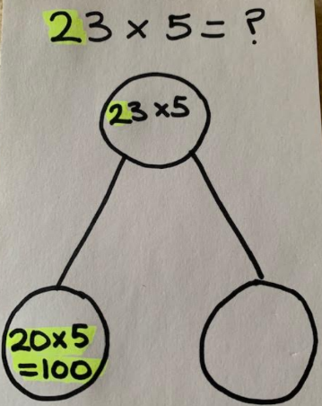 3. 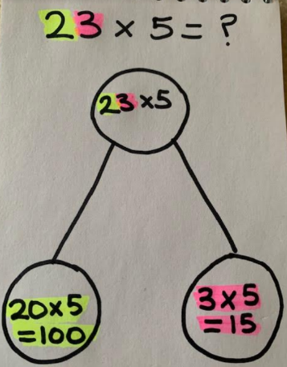 4.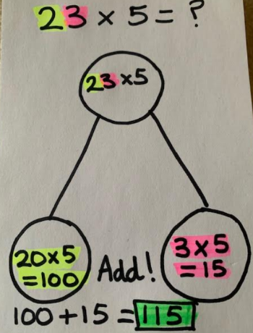

Now you try…
32 x 2 = 64 21 x 3 = 63 45 x 2 = 90 62 x 3 = 186 52 x 4 = 208
63 x 5 = 315
Year 4 Maths
Main activity
Complete at least 2 columns, more if you can!
Task 1 | Task 2 | Task 3 | Task 4
Practice  Have a go at these multiplications. Use the expanded method:  121 x 3 = 363  231 x 2 = 462  415 x 3 = 1245  241 x 5 = 1205  623 x 2 = 1246  324 x 5 = 1620 | Practice  Have a go at these multiplications. Use the expanded or short method:  136 x 4 = 544  263 x 5 = 1315  627 x 3 = 1881  721 x 6 = 4326  824 x 7 = 5768  982 x 9 = 8838 | Reasoning  Explain your answers.  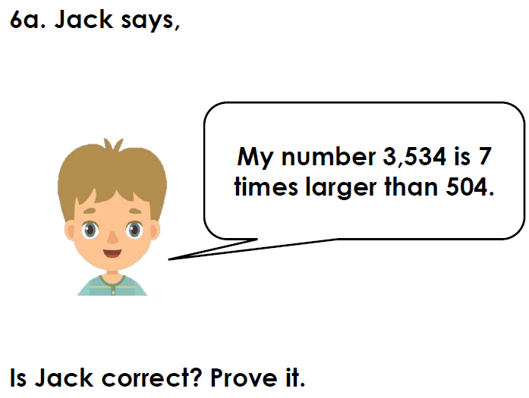  No, 504 x 7 = 3,528  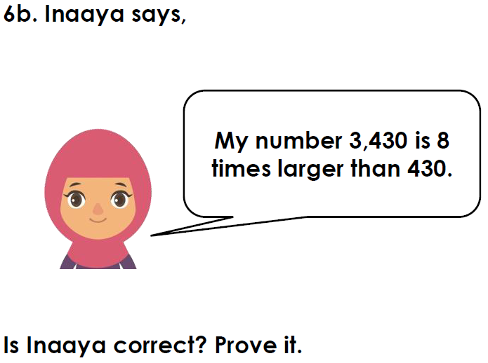  No, 430 x 8 = 3,440 | Problem solving  