Year 4 Maths
Steppingstone activity
Lesson 7
LO: To multiply 2-digit numbers by 1-digit
Success Criteria:
- Layout your multiplication accurately (brackets in line with answers)
- Multiply the ones
- Multiply the tens
- Add your answers together

Model
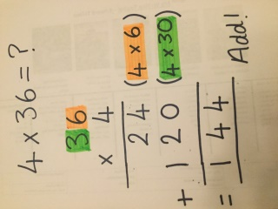
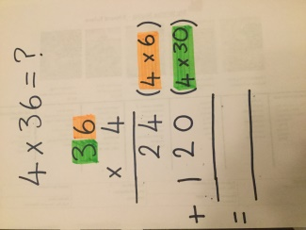
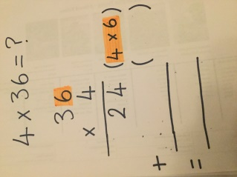
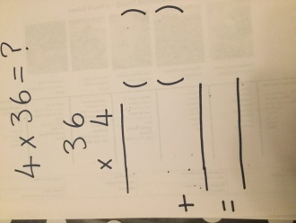
- 2. 3. 4.

Now you try…
54 x 3 = 162 72 x 4 = 288 37 x 5 = 185 66 x 8 = 528

Year 4 Maths
Main activity
Complete at least 2 columns, more if you can!
Task 1 | Task 2 | Task 3 | Task 4
Practice  Have a go at these multiplications. Use the expanded or short method:  242 x 6 = 1452  361 x 5 = 1805  905 x 7 = 6335  817 x 8 = 6536  443 x 9 = 3987  628 x 4 = 2512 | Practice  Which calculation is the odd one out?  C is incorrect because 0 x 3 = 0, not 3. The answer should be 1,620. | Reasoning  Explain your answers.  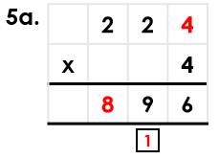  9a. No, 398 x 8 = 3,184 and 590 x 4 = 2,360 so the total is 5,544 | Problem solving  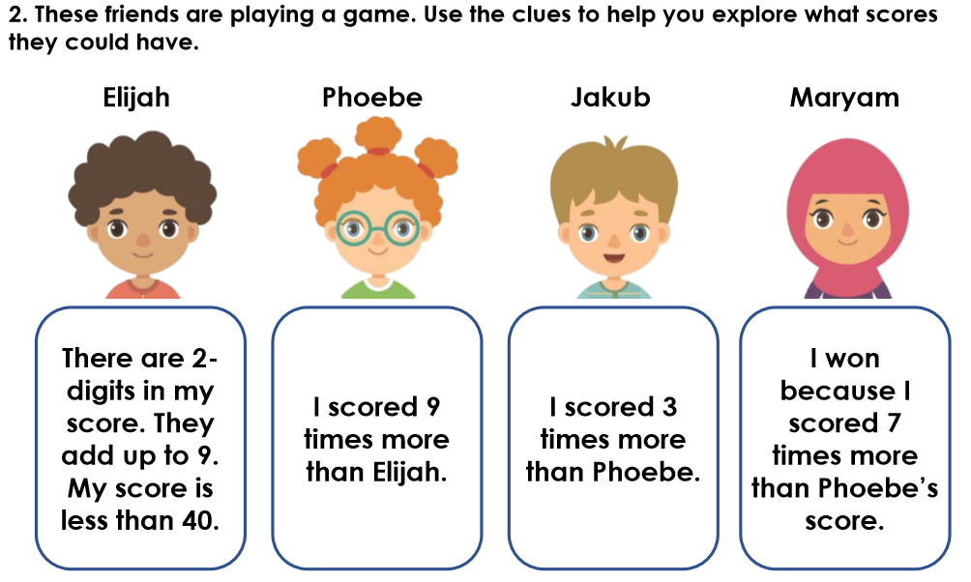  Various answers, for example: Elijah – 36 points, Phoebe – 324 points, Jakub – 972 points and Maryam – 2,268 points.

