Year 4 Maths
Steppingstone activity
Lesson 7
LO: To multiply 2-digit numbers by 1-digit
Success Criteria:
- Layout your multiplication accurately (brackets in line with answers)
- Multiply the ones
- Multiply the tens
- Add your answers together

Model
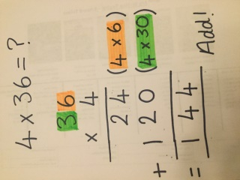
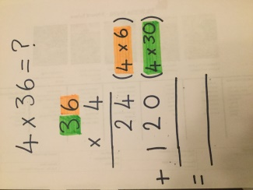
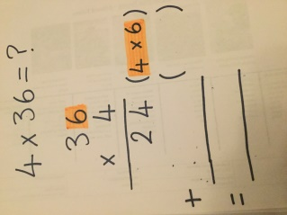
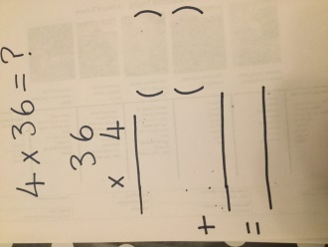
- 2. 3. 4.

Now you try…
54 x 3 = 72 x 4 = 37 x 5 = 66 x 8 =

Year 4 Maths
Lesson 7
LO: To multiply 3-digit numbers by 1-digit
Task:
You are going to practise multiplying! You can choose to do the expanded method or the short method.
Success Criteria:
- Layout your multiplication accurately
- Multiply the ones – carry any tens digit
- Multiply the tens – add any carried digit then carry over any hundreds digit
- Multiply the hundreds – add any carried digit then carry over any thousands digit

Model of short method (for expanded method see Lesson 6)
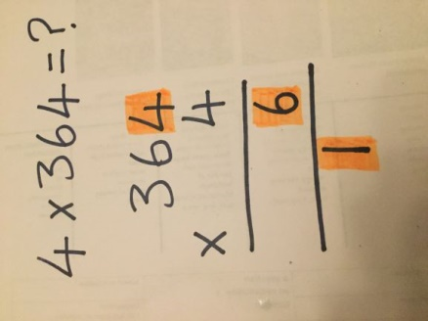
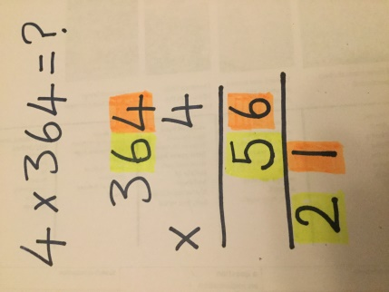
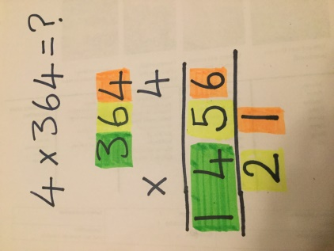
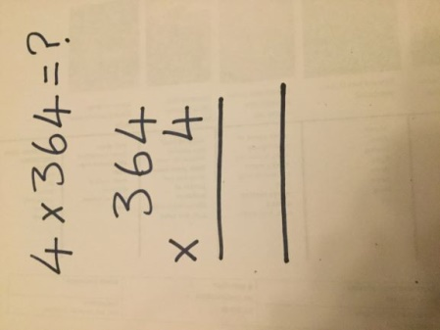
- 2. 3. 4.

Make sure all your answers are in the correct columns!!!

Year 4 Maths
Main activity
Complete at least 2 columns, more if you can!
Task 1 | Task 2 | Task 3 | Task 4
Practice  Have a go at these multiplications. Use the expanded or short method:  242 x 6 =  361 x 5 =  905 x 7 =  817 x 8 =  443 x 9 =  628 x 4 = | Practice  Which calculation is the odd one out?  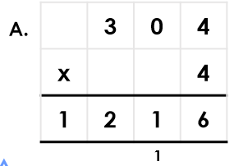  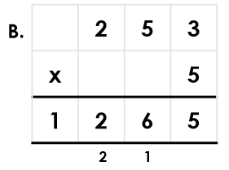  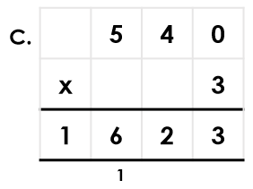 | Reasoning  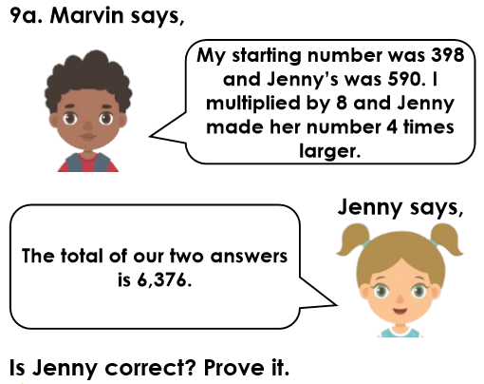  Explain your answers.  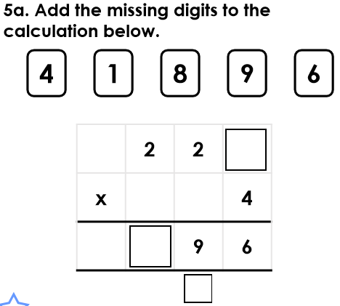 | Problem solving  