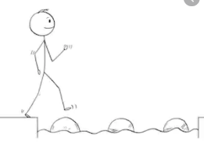
Year 4 Maths
Steppingstone activity
Lesson 8
LO: To solve multiplication word problems
Success Criteria:
- Read the problem carefully and identify the key numbers.
- Layout your multiplication accurately (brackets in line with answers)
- Multiply the ones
- Multiply the tens
- Add your answers together

Model
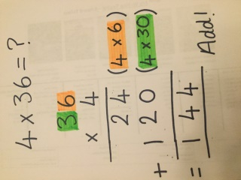
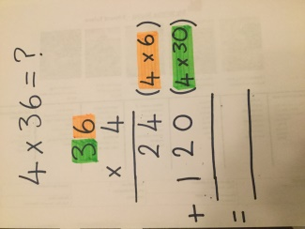
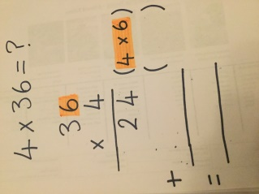
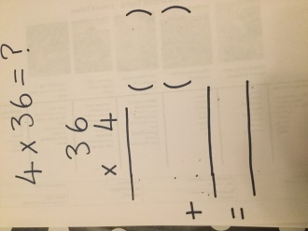
- 2. 3. 4. 5.

- Jane gave 5 of her friends 32 marbles at her birthday party. How many marbles did she have altogether? 160

- John ate 16 raisins every day for 9 days. How many raisins did he eat altogether? 144

- Mary and Ben went for a walk in the English countryside for one week. They were able to walk 12km every day. How many km did they walk altogether? 84km

Year 4 Maths
Lesson 8
LO: To solve multiplication word problems
Task:
You are going to practise multiplying to solve word problems! You can choose to do the expanded method or the short method.
Success Criteria:
- Read the problem carefully.
- Identify the calculations required (there might be more than one).
- Layout your calculations accurately
- Solve the calculations.
- Check that you have answered the question properly.

For models of expanded and short multiplication methods, see lessons 6 and 7.

Year 4 Maths
Main activity
Complete at least 1 column, more if you can!
Task 1 – one step | Task 2 – more than one step | Task 3 – multiple steps (extra challenging!)
1. John ate 37 grapes every day for 9 days. How many grapes did he eat altogether? 333  2. Each day the new museum in the town of is allowed 430 tourists. How many tourists are allowed in 3 days? 1290  3. If there are 563 jelly beans in one large bucket, how many jelly beans are in 4 buckets? 2252 | 1. A child has 2 complete albums of football stickers. The first has 28 pages with 5 stickers on each page, and the second has 36 pages with 6 stickers on each page. How many football stickers are there altogether? 356  2. A teacher has 4 packs of colouring pencils, each with 252 pencils, and 9 packs of writing pencils, each with 126 pencils. How many pencils are there altogether? 3402  3. Finley and Ted went on a long cycling holiday in Germany. In the first week they cycled 102 km a day and in the second week the cycled for 98 km a day. How many km did they cycle altogether? 1400km | A machine produces 356 dice in one hour.  The machine runs for 8 hours a day, 6 days a week.  The dice are sold in pairs, packs of 5 and packs of 8.  Out of one week’s production of dice, the following are made:  • 2500 pairs  • 1200 packs of 5  • 760 packs of 8  How many dice are left over after the packs are made?  5000 + 6000 + 6080 = 17088 dice in a week.  17080 are packed, so 8 are left over.

