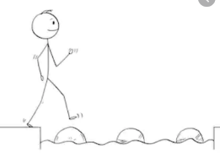
Year 4 Maths
Steppingstone activity
Lesson 9
LO: To divide 2 digits by 1digit
Success Criteria:
- Read the calculation carefully. How many are you dividing by?
- Share out the tens equally.
- Share out the ones equally
- How much do you have in each part?
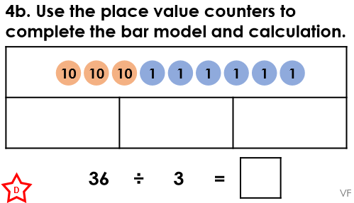
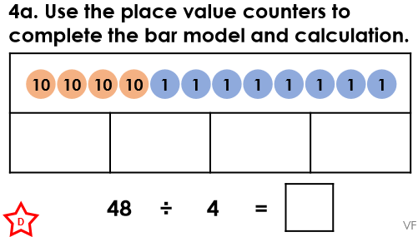
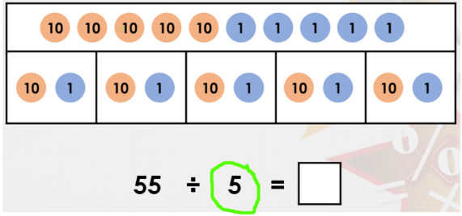
Model Now you try…

1.

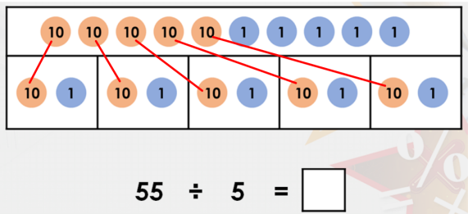
2.

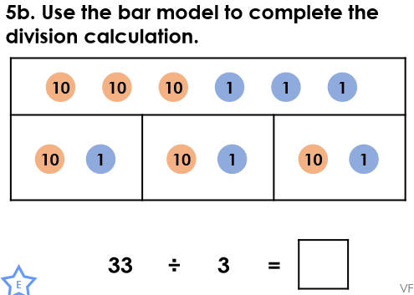
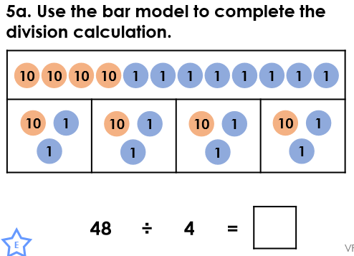
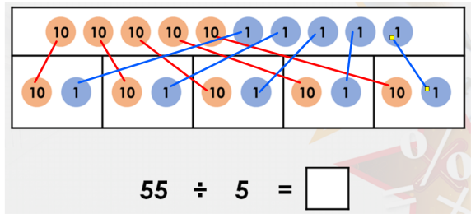
3.

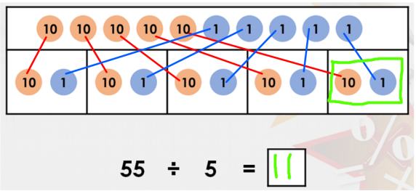
4.

Year 4 Maths
Lesson 9
LO: To divide 2 digit by 1 digit
Task:
You are going to practise dividing! You will be using part-whole models.
Model:
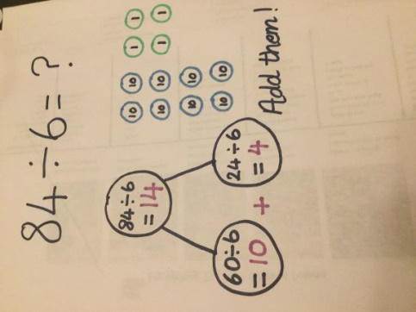
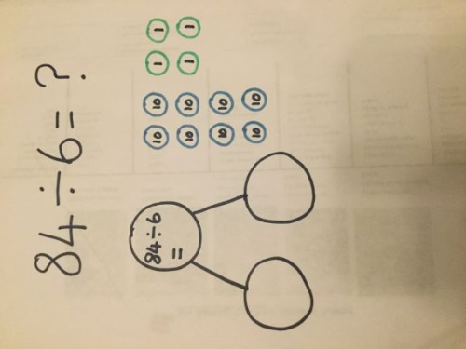
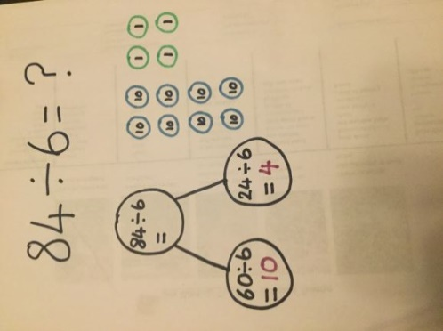
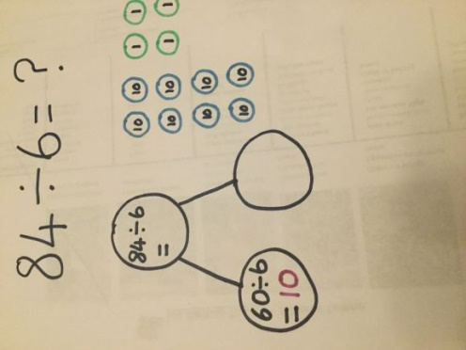

Look at the pictures.
Can you work out what I’ve done?
Why did I choose to do 60 ÷ 6?
Discuss this with someone at home.

Year 4 Maths
Main activity
Complete at least 2 columns, more if you can!
Task 1 | Task 2 | Task 3 | Task 4
Practice  Complete the part-whole models.  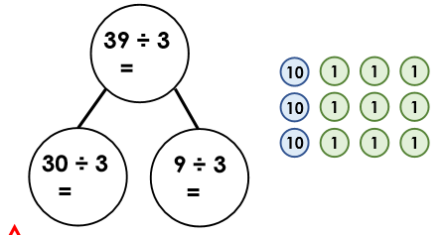  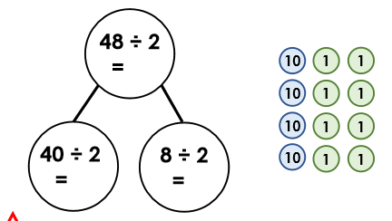  Now draw and complete a part-whole model for:  55 ÷ 5 = | Practice  Complete the part-whole models.  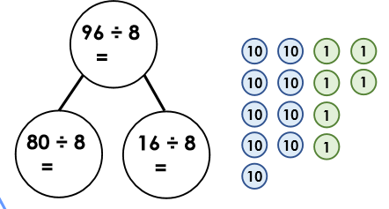  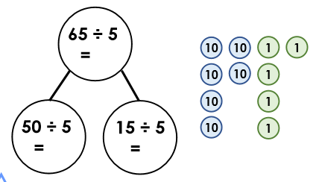  Now draw and complete part-whole models for:  48 ÷ 3 =  72 ÷ 4 = | Reasoning  Explain your answers.  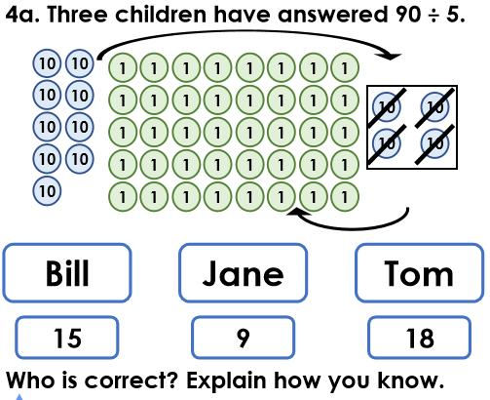  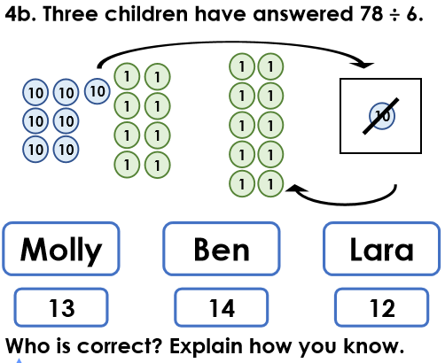 | Problem solving  