**Year 4 Reading**  **All children:**

**Date: Friday 2nd April 2020  
LO: To discuss likes and dislikes of a text  
LO: To make a prediction based on the text**

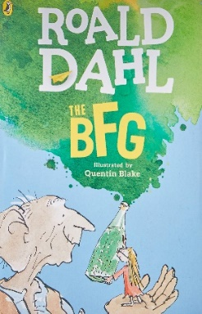

**Task:**

**Read and discuss:**

We would like you to enjoy sharing the next chapters ‘Frobscottle and whizzpoppers’ and ‘Journey to dream country’ with an adult or older sibling.

As you are reading, discuss which words and phrases you like and dislike. At the end, summarise verbally what has just happened in these 2 chapters.

**Predict:**

Have a go at drawing what you think dream country looks like! You can use paints, pencils, crayons, collage or any medium of art you like!

Below are some ideas:

