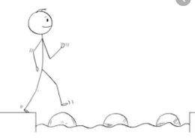
Year 4 Reading
Steppingstone activity
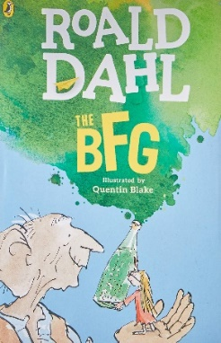
Date: Wednesday 1st April 2020
LO: To find clues in a text
Task:
Share the next chapter ‘Snozzcumbers’, with an adult or older sibling. Here we find out what the BFG likes to eat!
You have been given some inferences.
You need to find clues in the text that back up those inferences.
Your clues are on the first 2 pages.

Inference: | Clues in the text:
The BFG does not like snozzcumbers. | E.g.  - The BFG says “Nothing is growing except for one icky-poo vegetable. It is called the snozzcumber.
Sophie doesn’t believe some of the things the BFG says.
Sophie was shocked by the look of the snozzcumber
Sophie felt sorry for the BFG.

Year 4 Reading
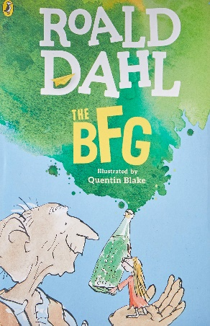
Date: Wednesday 1st April 2020
LO: To find clues in a text
Task:
Read the next chapter of the BFG ‘Snozzcumbers’. Here we find out what the BFG likes to eat!
You have been given some inferences.
You need to find clues in the text that back up those inferences. Try to find more than one clue for each inference.

Inference: | Clues in the text:
The BFG does not like snozzcumbers. | E.g.  - The BFG says “Nothing is growing except for one icky-poo vegetable. It is called the snozzcumber.
Sophie doesn’t believe some of the things the BFG says.
Sophie was shocked by the look of the snozzcumber
Sophie felt sorry for the BFG.
Sophie did not want to be hit by pieces of snozzcumber!
Sophie wants to be friends with the BFG.
Us

