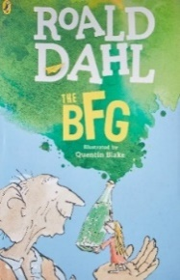
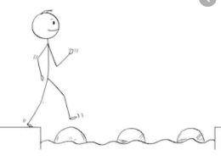
Year 4 Reading
Steppingstone activity
Date: Tuesday 12th May 2020
LO: To summarise and order events in a text
Task:
Share the rest of chapter 18- The Palace (pgs 116-117) with an adult or older sibling.
- Order the events in Sophie and the BFG’s plan so far
- Pretend you are Sophie. Draw instructions for the BFG including images and words.
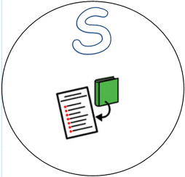

Event in the plan so far | Order (Numbers 1-6)
Travel from the Giant’s country to London, England (You will know you are in England as you will be able to see green fields).
Find all the dream you need and tip them into a huge jar.
Pour the dream in to the end of the trumpet, take a deep breath and blow, aiming for Queen.
Cross Hyde Park Corner, then the park- you will be in the Queen’s back garden.
Get a giant eggbeater and whisk the dreams. Bubbles come out- they are the bits of dream you do not want.
Find the Queen’s bedroom window.

Steppingstone activity
Instructions for the BFG
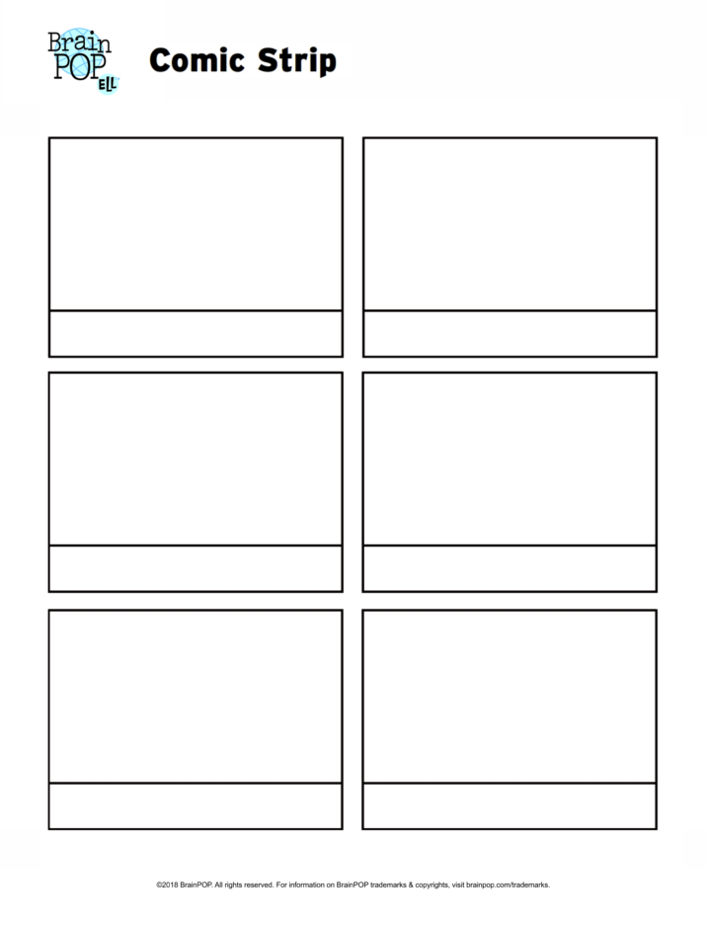
Year 4 Reading
Main activity
Date: Tuesday 12th May 2020
LO: To summarise and order events in a text
Task:
Read the rest of chapter 18- The Palace (pgs 116-117).
- Order the events in Sophie and the BFG’s plan so far
- Pretend you are Sophie. Draw instructions for the BFG including images and words. You can decide how you want lay these out!

Event in the plan so far | Order (Numbers 1-9)
Put the jar securely in the pocket of your cloak.
Travel from the Giant’s country to London, England (You will know you are in England as you will be able to see green fields).
Find all the dream you need and tip them into a huge jar.
Pour the dream in to the end of the trumpet, take a deep breath and blow, aiming for Queen.
The dream will jump about wildly- that is because it’s a Trogglehumper (nightmare).
Groups of houses will appear- this is how you will know you are getting closer to London
Cross Hyde Park Corner, then the park- you will be in the Queen’s back garden.
Get a giant eggbeater and whisk the dreams. Bubbles come out- they are the bits of dream you do not want.
Find the Queen’s bedroom window.

