Year 4 Writing
Lesson 4
LO: To write the beginning of a narrative
Task (with links):
Watch this video clip: https://www.literacyshed.com/takingflight.html
We want you to write your own sequel adventure for one of our character.
Use your success criteria, toolkit, models, checklist and planning to support writing your sequel over 5 paragraphs.
Year 4 spelling words: Can you include ‘–tion’, ‘-sion’, -‘ssion’, ‘-cian’ words? Possession, attention
Success Criteria:
- Look at your plan
- Include expanded noun phrases
- Include fronted adverbials
- Include exciting adjectives
- Write in the third person
- Use your toolkit to create your sentences
- Check and edit your writing using your checklist

Fronted Adverbials | Adjectives | Nouns | Verbs
In the trees,  Above them,  Across the sky,  Beside the river,  Up in the clouds,  As quick as a flash,  In the distance,  In the clouds,  As soon as he could,  Between the sea and the sky,  Everywhere,  Out of nowhere, | tropical dense  tangled fearsome  swampy gigantic  desolate humid  green wild  vast exotic  colourful mysterious  adventurous  enormous  elegant precious  sparkling energetic  courageous  comfortable | Boy  Man  Grandpa  Tony  Monkey  Spaceship  Aliens  Plane  Car  Planets  River  Temples  Clouds | waited hid  dangled paddled  climbed scoured  flew searched  Sailed wandered  drifted confused  swung depressed  embarrassed  drifted drove  climbed swam  crawled jumped
Conjunctions: when, if, because, although, after, once, until, while, but, so

Main Idea for the Paragraph | Model:
Introduction  Where is the story set?  Who are your characters? | One sunny, bright day, Tony and his Father’s were tidying up their cramped, busy garage. Everyday, Tony would tear through his father’s aged, tatty belongings in the garage, looking for treasure...
Build up  Where do they need to go?  Why do they need to go on an adventure? | Out of the corner of his eye, he saw something sparkle on the top shelf. An old ripped photograph of his father diving in the vast blue ocean...
Problem  What problem do they run into?  What do they do to face it? | As they raced on the Flyer, very transformed into a long metallic submarine, scouring the deep, dark ocean bed. All of a sudden...
Resolution  How do they fix the problem? | They meandered and weaved their way through the tough, tangled seaweed, as the shark chased intensively behind them. Abruptly, the shark slammed to a stop as its long, wriggling fin was caught in a net. This was their chance!
Ending  What happens when they go back home?  How do they feel about finishing their adventure together? | As they breached the beach, the world around them transformed back in their driveway. They were home...

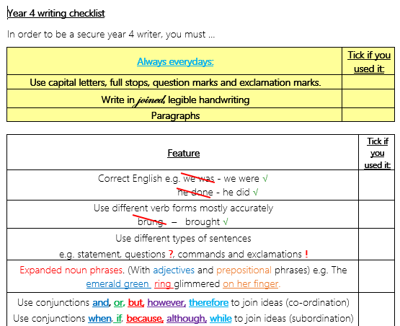
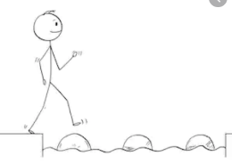

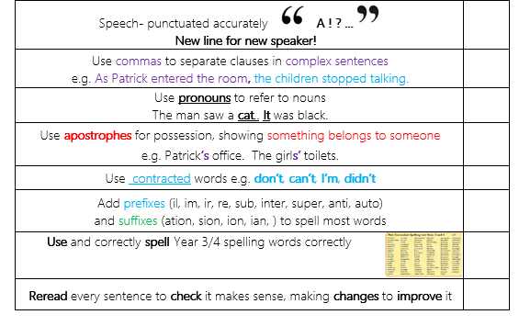

Year 4 Writing
Steppingstone activity
LO: To write the beginning of a narrative
Task (with links):
Watch this video clip: https://www.literacyshed.com/takingflight.html
We want you to write your own sequel adventure for one of our character.
Use your success criteria, toolkit, models, checklist and planning to support writing your sequel over 3 short paragraphs.
Year 4 spelling words: Can you include ‘–tion’, ‘-sion’, -‘ssion’, ‘-cian’ words? Possession, attention
Success Criteria:
- Look at your plan
- Include expanded noun phrases
- Include fronted adverbials
- Include exciting adjectives
- Write in the third person
- Use your toolkit to create your sentences

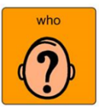  Nouns | 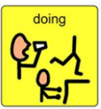  Verbs | Adjectives | Nouns
Boy  Man  Grandpa  Tony  Monkey  Plane  Car  Radio Flyer | waited hid  dangled paddled  climbed scoured  flew searched  Sailed wandered  drifted  swung  embarrassed  drifted drove  climbed swam  crawled jumped | tropical dense  tangled fearsome  swampy gigantic  desolate humid  green wild  vast exotic  colourful mysterious  adventurous  enormous  elegant precious  sparkling energetic  courageous  comfortable | River  Trees  Temple  Canyon  Jungle  Waterfalls  Sky  Spaceship  Aliens  Plane  Car  Planets  River  Temples  Clouds

Main Idea for the Paragraph | Model:
Beginning  How do we meet your character?  Where does it start?  What makes your character go on their adventure?  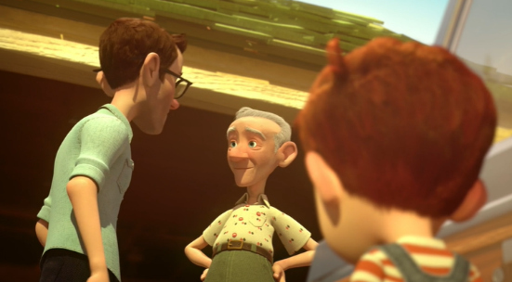 | One sunny, bright morning, there lived a young, little boy called Tony. Tony lived in a small, cramped house with his Father, Mother and Grandpa. He loved adventures and was searching for his next exciting, thrilling trip!
Middle  Where is the setting for their adventure?  Where do they go?  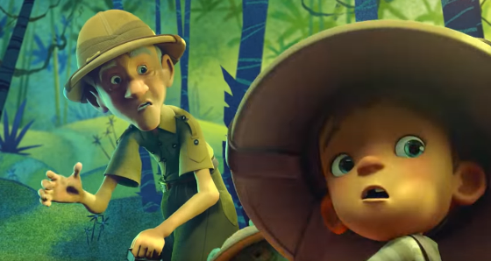  What problems do they come across? | Suddenly, they appeared in a dangerous jungle. Tony could see towering, looming trees all around them. Monkeys swung through the tropical, beautiful trees. As quick as a flash, one monkey swung passed and stole their map!
Ending  What happens to your character at the end?  Do they solve any problems they have encountered?  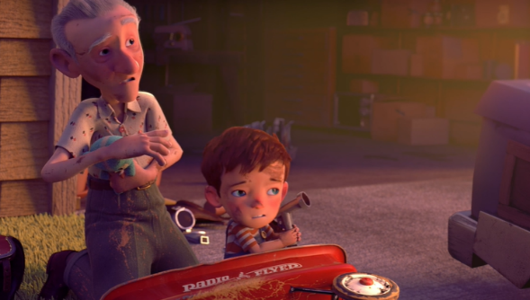 | Finally, they returned home. What an adventure that was! They fought the tricky, naughty monkeys and won! Now they were back to their normal, boring home. When was the next adventure?

