Year 4 Writing
Lesson 2
LO: To write in the first person
Task (with links):
Watch this video clip: https://www.literacyshed.com/takingflight.html
Imagine, Dad finds his old diary in the garage and reads about all the wonderful and exciting adventures he used to have with Grandpa.
Write about one of Dad’s adventures with Grandpa when he was young, diary style.
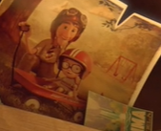

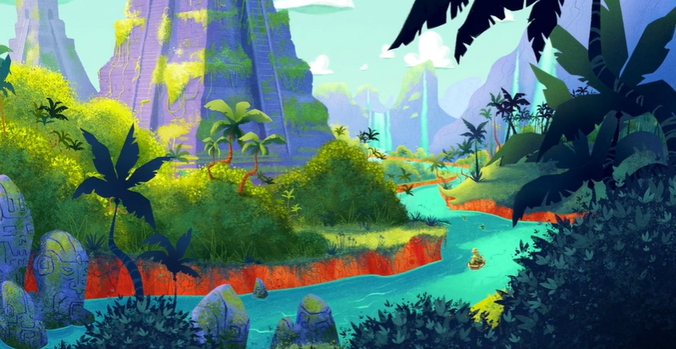

Success Criteria:
- Watch the video
- Choose a location for your adventure
- Use first person ‘I’
- Use expanded noun phrases
- Use fronted adverbials
- Use conjunctions
- Use subordinate clauses
Word bank:
Fronted Adverbials | Adjectives | Nouns | Verbs
In the trees,  Above them,  Across the sky,  Beside the river,  Up in the clouds,  As quick as a flash,  In the distance, | tropical dense  tangled fearsome  swampy gigantic  desolate humid  green wild  vast exotic  colourful mysterious | Boy  Man  Grandpa  Tony  Monkey  River  Temples | waited hid  dangled paddled  climbed scoured  flew searched  Sailed wandered  drifted  swung

Model
Dear Diary,
As we embarked on our journey, Dad whispered quietly in my ears. “Ssssshhh. We must not wake the aggressive, tricky monkeys.” Monkeys? Why would there be monkeys here? All of a sudden, the world around me transformed in to a beautiful, colourful jungle. Towering, menacing mountains and enormous, exotic temples loomed over Dad and I as we weaved and meandered through the jungles river network.

Year 4 Writing
Steppingstone activity
Lesson 2
LO: To write in the first person
Task (with links):
Watch this video clip: https://www.literacyshed.com/takingflight.html
Imagine, Dad finds his old diary in the garage and reads about all the wonderful and exciting adventures he used to have with Grandpa.
Write about Dad’s adventure to space with Grandpa when he was young, diary style.

Word bank:
Nouns | Verbs | Adjectives | Nouns
Boy  Man  Grandpa  Tony  Monkey  River  Temples | waited hid  dangled drifted  paddled  climbed scoured  flew searched  Sailed wandered | tropical dense  tangled fearsome  swampy gigantic  desolate humid  green wild  vast exotic  colourful mysterious | Boy  Man  Grandpa  Tony  Monkey  River  Temples
Success Criteria:
- Watch the video
- Choose a location for your adventure
- Use first person ‘I’
- Use expanded noun phrases
- Use colourful semantics to structure you sentences
Steppingstone Model
Dear Diary,
The world was full of colour. Huge, towering temples loomed over the twisting narrow rivers. Cheeky, brave monkeys dangled green, large trees. Exotic colours filled the sky. Beautiful, elegant birds sailed through the blue, clear sky.

