Year 4 Writing
Lesson 3
LO: To design and describe a setting
Task (with links):
Watch this video clip: https://www.literacyshed.com/takingflight.html
Also on: https://www.youtube.com/watch?v=Gj6V-xZgtlQ ‘Taking Flight’
In preparation for our Big Write, we first need a setting for our adventure. Today, draw, colour and get creative with your own adventure setting. Where will our characters go next?
Once you have completed the picture, add descriptive sentences around or below your picture
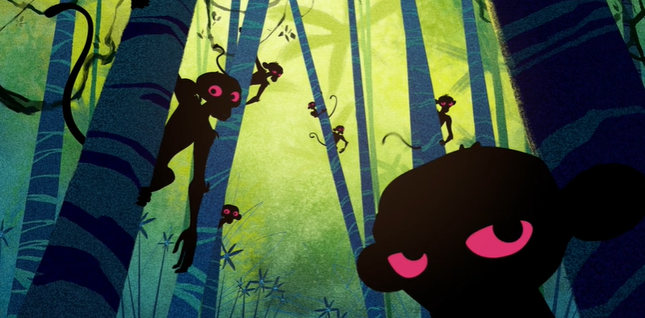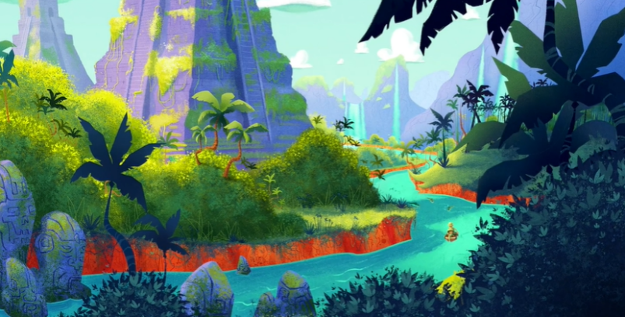
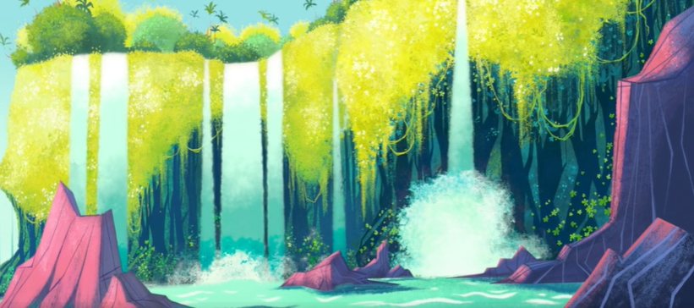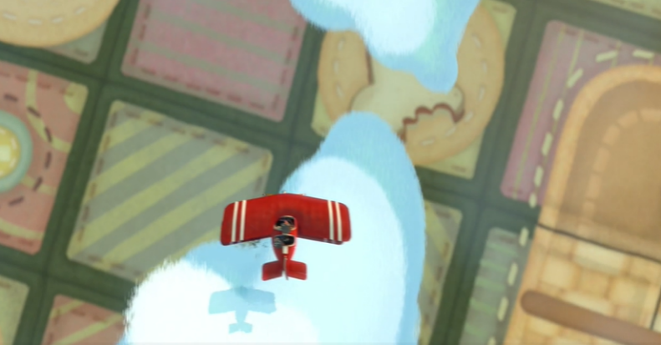
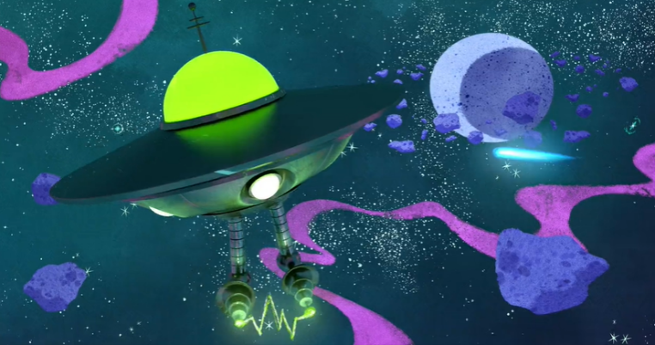
Adjective word bank
tropical dense tangled fearsome
swampy gigantic desolate humid
green wild vast exotic
colourful mysterious
Success Criteria:
- Watch the film
- Draw your own setting.
- Add colour to your setting
- Add descriptive sentences
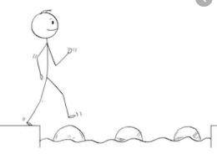
Year 4 Writing
Steppingstone activity
Lesson 3
LO: To design and describe a setting
Task (with links):
Watch this video clip: https://www.literacyshed.com/takingflight.html
In preparation for our Big Write, we first need a setting for our adventure. Today, draw, colour and get creative with your own adventure setting. Where will our characters go next?
Once you have completed the picture, add expanded noun phrases around or below your picture
Success Criteria:
Adjective word bank
tropical dense tangled fearsome
swampy gigantic desolate humid
green wild vast exotic
colourful mysterious
- Watch the film
- Draw your own setting.
- Add colour to your setting
- Add expanded noun phrases

