Year 4 Writing
Lesson 4
LO: To plan a narrative
Task (with links):
Watch this video clip: https://www.literacyshed.com/takingflight.html
Imagine, Tony, his Father and Grandpa need to go on one last adventure. Where will they go and what will happen?
Using your setting from yesterday, choose one of or two of our characters to send on a new adventure.
Today, we need to plan our sequel adventure for ‘Taking Flight’

Year 4 spelling words: Can you include ‘–tion’, ‘-sion’, -‘ssion’, ‘-cian’ words? Possession, attention
Success Criteria:
- Choose a character for your adventure
- Use your setting for your adventure
- Plan the introduction and build up. Where will it start?
- Plan the problem. What issues will they encounter?
- Plan the resolution and ending. How is it all resolved?
Choose a character
Tony Dad Grandpa

On the following page is a story mountain model/template for you to use.
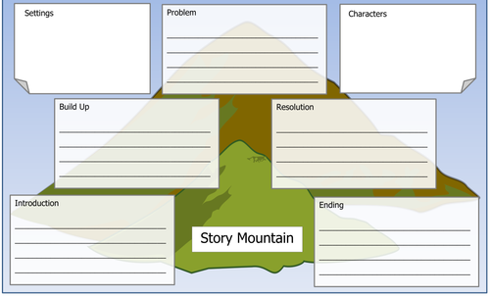
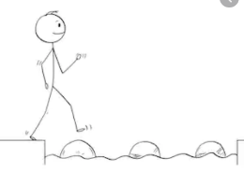
Year 4 Writing
Steppingstone activity
LO: To plan a narrative
Task (with links):
Watch this video clip: https://www.literacyshed.com/takingflight.html
Imagine, Tony, his Father and Grandpa need to go on one last adventure. Where will they go and what will happen?
Using your setting from yesterday, or one provided, choose one of our characters to send on a new adventure.
Today, we need to plan our sequel adventure for ‘Taking Flight’
Year 4 spelling words: Can you include ‘–tion’, ‘-sion’, -‘ssion’, ‘-cian’ words? Possession, attention
Success Criteria:
- Choose a character for your adventure
- Choose a setting for your adventure
- Draw a picture of the opening scene. Write a descriptive sentence about it
- Draw a picture of the build up. Write a descriptive sentence about it
- Draw a picture of the problem. Write a descriptive sentence about it
- Draw a picture of the resolution. Write a descriptive sentence about it
- Draw a picture of the ending. Write a descriptive sentence about it
Choose a character
Tony Dad
Choose a setting
Space Jungle Or your own
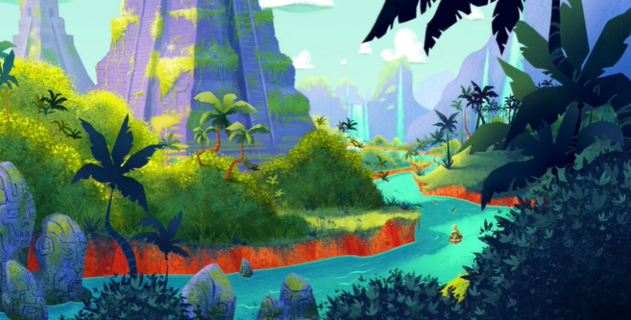
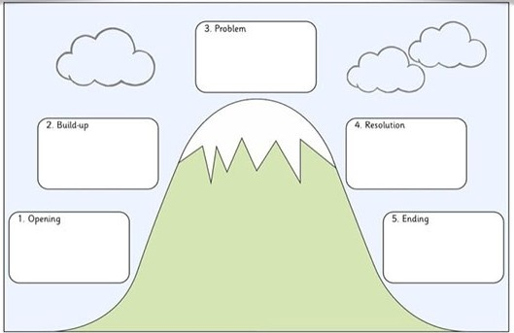
Use this story mountain model/template

