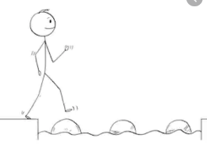
Year 1 Maths
Activity for everyone
Lesson 8
LO: To explore weight and mass
Steps to success:
- Watch the video and make your own balance scale https://www.youtube.com/watch?v=tK8mSIEtTUw
- Find different objects to weigh from around the house.
- Before you weigh them, try to predict which will be heavier and which will be lighter.

Children will have some understanding of heavy and light from their own experience of carrying objects. In Year 1, they are introduced to weight and mass for the first time. Children should begin by holding objects and describing them, using vocabulary such as
heavy, light, heavier than, lighter than before using the scales to check.
The children may believe that larger objects are always heavier and this misconception should be explored.
