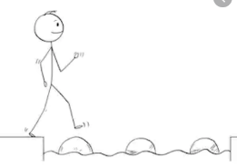
Year 1 Maths
Steppingstone activity
Lesson 9
LO: To measure mass
Steps to success:
- Use the balance scale you made yesterday https://www.youtube.com/watch?v=tK8mSIEtTUw
- Find a group of objects which are all the same (eg lego bricks or wooden building blocks of the same size and shape).
- Choose some objects to weigh, eg a banana.
- You are going to find out how many blocks balance with the banana.
Model
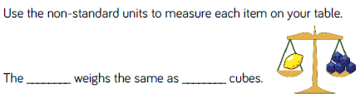
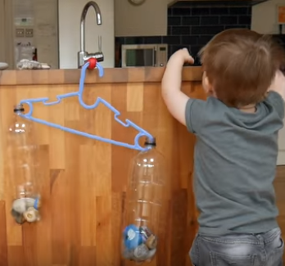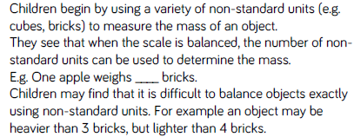

Year 1 Maths
Main activity Complete at least 2 tasks, more if you can.
Task 1 | Task 2 | Task 3
Choose your own objects.  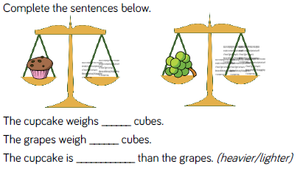 | Choose your own objects.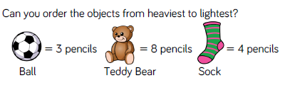 | Using cubes, find the mass of four objects from around your house. Order them from heaviest to lightest.
 | Task 4
 | 