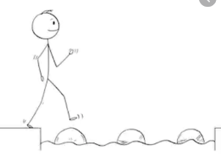
Year 1 Maths
Steppingstone activity
Lesson 10
LO: To compare mass
Steps to success:
- Use the balance scale you made https://www.youtube.com/watch?v=tK8mSIEtTUw
- Find a group of objects which are all the same (eg pencils or wooden building blocks of the same size and shape).
- Choose some objects to weigh, eg a banana.
- You are going to compare the mass of the different objects.
Model
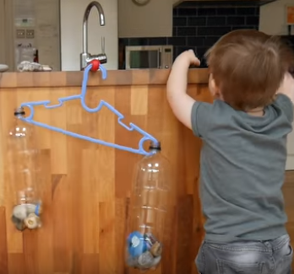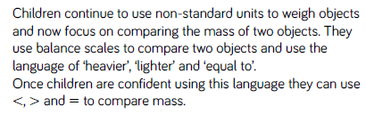

Year 1 Maths
Main activity Complete at least 2 tasks, more if you can.
Task 1 | Task 2 | Task 3
Choose your own objects.  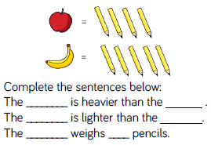 | 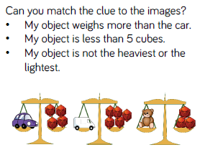 | 