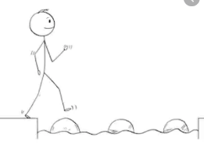
Year 2 Maths
Steppingstone activity
Lesson 1
LO: To partition a 2-digit number into tens and ones
Success Criteria:
- Draw a part-whole model
- Write a 2-digit number into the ‘whole’ of the model
- Use Base 10 jottings to represent the tens in one ‘part’ and the ‘ones’ in the other
- Write a number sentence beneath each part-whole model to match the Base 10 representation
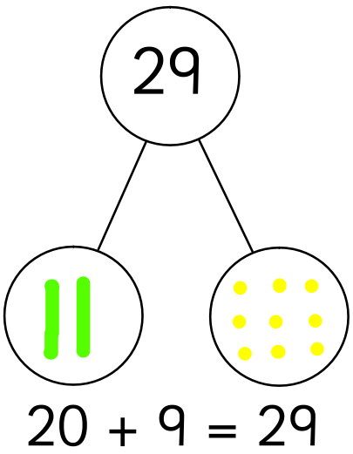
Model:
Whole
= ten (10)

= one (1)
Part
Part

Now you try…
33 45 57 62 99
Then, come up with some of your own!

Year 2 Maths
Lesson 1
LO: To partition 2-digit numbers into different combinations of tens and ones
Task:
You are going to be partitioning numbers to show three different ways to make the same amount
Success Criteria:
- Draw three part-whole models.
- Write 25 in each ‘whole’ of the model.
- Use Base 10 jottings to represent three different ways to make 25.
- Write a number sentence beneath each part-whole model to match the Base 10 representation e.g. 20 + 5 = 25.

Model:
Whole
Whole
Whole
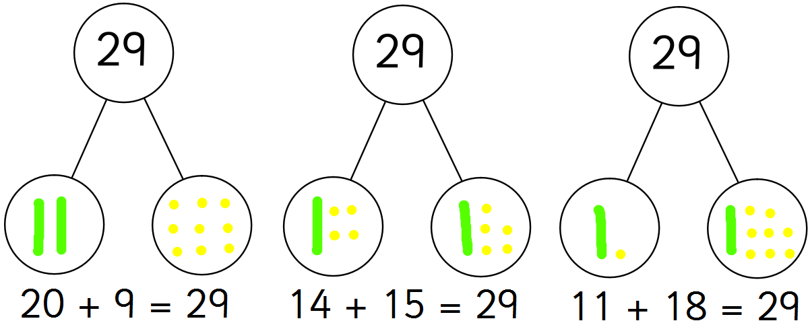
Part
Part
Year 2 Maths
Main activity
Complete at least 2 columns, more if you can!
Task 1 | Task 2 | Task 3 | Task 4
Practice  Have a go at finding three different ways to make these numbers using a part-whole model:  36  47  58  99 | Practice  Have a go at completing these calculations to make a total of 100.  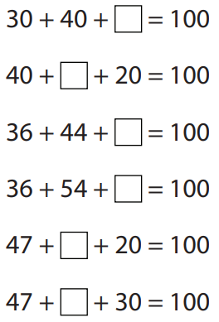 | Reasoning  Explain your answers.  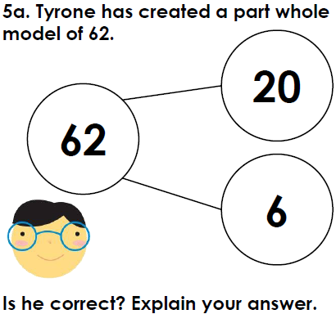  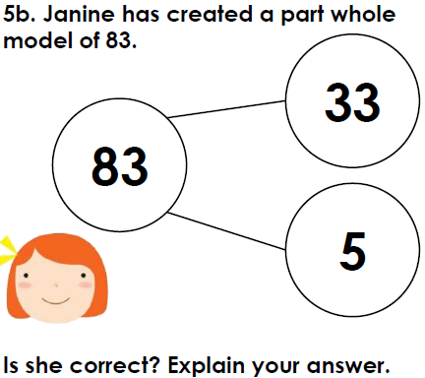 | Problem solving  Complete the extended part-whole model:  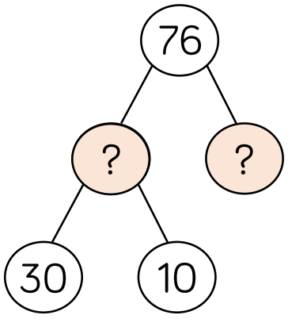  Can you create your own extended part-whole model for 76?

