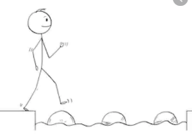
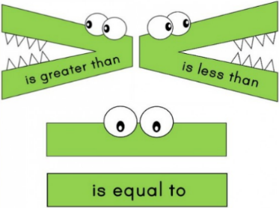
Year 2 Maths
Steppingstone activity
Lesson 1
LO: To count in 2s
Success Criteria:
- Practice counting in 2s, using the two times table provided
- Answer the questions in your book
1. Count the cherries in 2s.  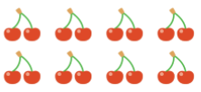  How many cherries are there in total?  If you can, write the multiplication sentence:  ____ x 2 = ____ | 2. Count the wellies in 2s.  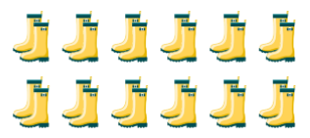  How many wellies are there in total?  If you can, write the multiplication sentence:  ____ x 2 = ____ | 3. Complete the sequences by counting in 2s:  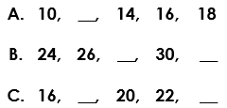  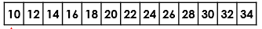
4. Complete the sequences by counting in 2s:  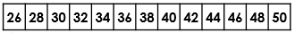  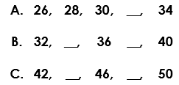 | 5. Answer the two times table questions:  1 x 2 =  2 x 2 =  3 x 2 =  4 x 2 =  5 x 2 =  6 x 2 = | 6. Answer the two times table questions:  7 x 2 =  8 x 2 =  9 x 2 =  10 x 2 =  11 x 2 =  12 x 2 =
Model:
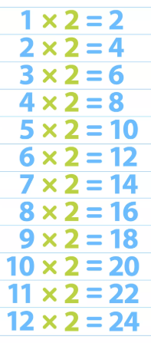
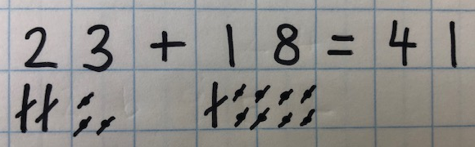
Year 2 Maths
Lesson 1
LO: To subtract two 2-digit numbers
Task:
You are going to be using Base 10 jottings for subtraction with exchange
Success Criteria:
- Write the number sentence (e.g. 33 - 18 =)
- Represent the first number as tens and ones using Base 10 jottings (you do not need to draw the second number!)
- Exchange one of the tens for ten ones
- Cross off the amount you are subtracting
- Count together the remaining tens and ones, then write the answer to complete your number sentence

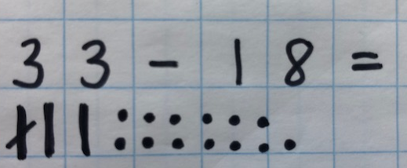
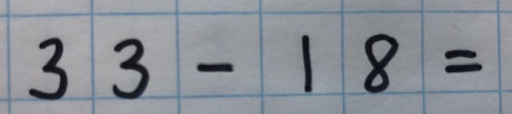
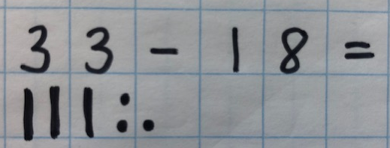
Model:
3.
2.
1.

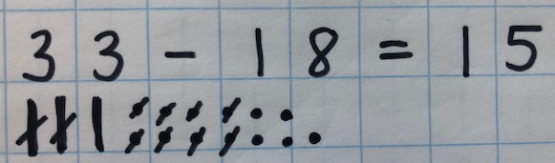
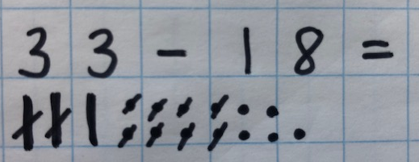
5.
4.

Year 2 Maths
Main activity
Complete at least 2 columns, more if you can!
Task 1 | Task 2 | Task 3 | Task 4
Practice  Use Base 10 jottings to answer these calculations:  36 - 17 =  43 - 14 =  45 - 16 =  54 - 29 =  61 - 35 = | Practice  Use Base 10 jottings to answer these calculations:  32 - 19 =  37 - 18 =  54 - 25 =  71 - 36 =  112 - 36 - 15 =  132 - 28 - 24 = | Reasoning  Explain your answers.  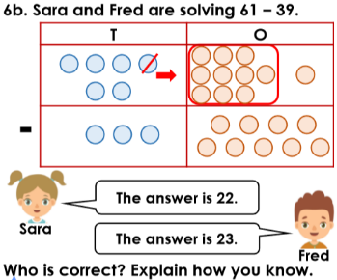  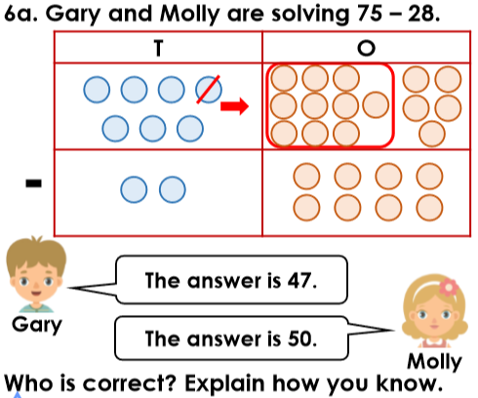 | 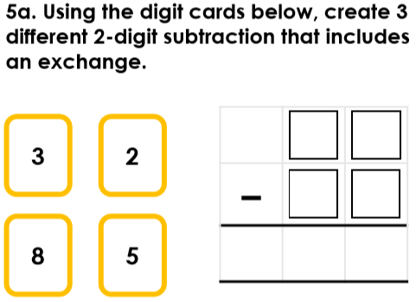  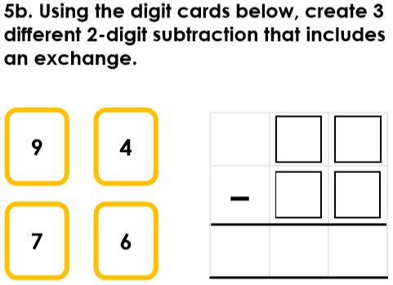  Problem solving

