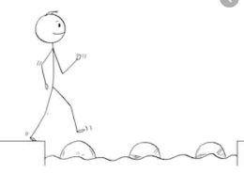
Year 2 Science
Week 2
Stepping Stone Activity
Materials
LO: To identify different materials
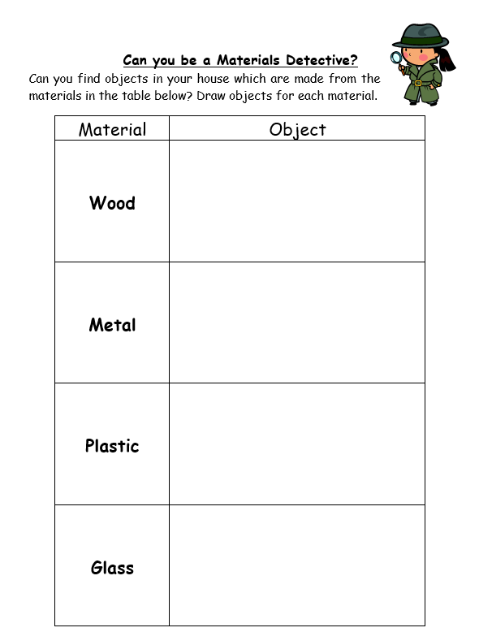

Success Criteria:
- Find at least one object that is made from each material above
- Draw a picture of each object

Challenge: Can you describe the material of the object using adjectives?

Year 2 Science
Week 2
Materials
LO: To identify different materials

Success Criteria:
- Find at least one object that is made from each material above
- Draw a picture of each object
- Name the different objects and describe the materials by writing full sentences using adjectives from the word mat on the next page below

EG: The jug is made from glass and it is transparent. It is smooth and hard and is waterproof.
Challenge: Choose one of your objects and discuss the suitability of the material- Why is this a good material to use? What would not be a suitable material for the job? Why?
EG: Fabric would not be a good material to make a jug because it is absorbent.

