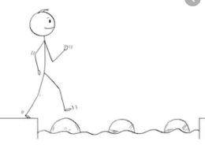
Year 2 Science
Week 1
Stepping Stone Activity
Materials
LO: To describe the properties of different materials

Look at the different objects below:
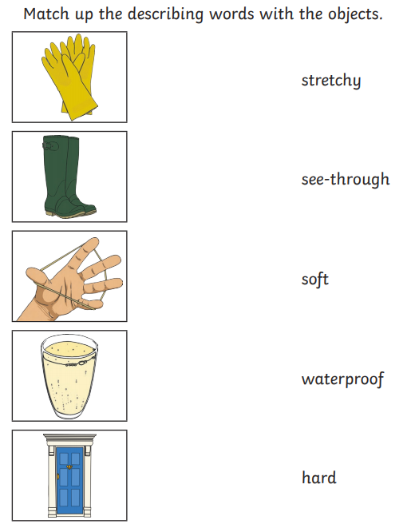

Word bank: glass, wood, rubber
Success Criteria:
- Draw a picture of each object in your book.
- Choose from the words to describe that object.

Challenge: Can you label the objects with the materials they are made from?

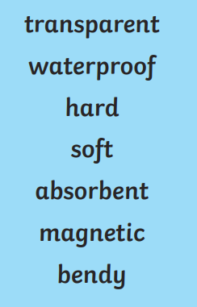
Year 2 Science
Week 1
Materials
LO: To describe the properties of different materials

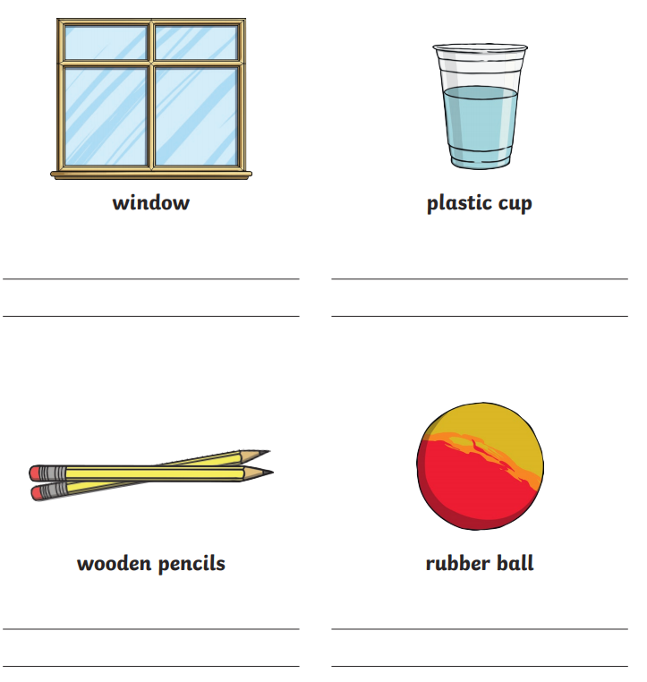

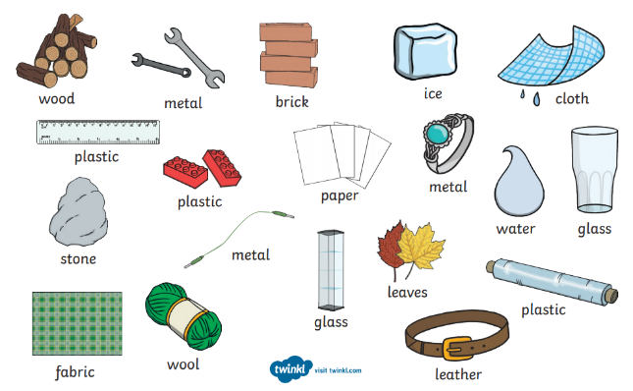

Success Criteria:
- Look at the different objects (window, pencils, cup and ball)
- Write sentences using key words to describe the objects and their properties.

Challenge: Write about another object that is made from the same material.

