Year 2 Topic
Lesson 1
How can we remember the Great Fire of London?
LO: To create a purposeful monument based on design criteria
Task (with links):
You are going to be designing a monument to encourage people to remember the Great Fire of London!
You can use whatever resources you have at home (pencils, felt tips, crayons). Be as creative as possible!
Think about what features you could include (for example The Monument was built 202 feet tall because it is 202 feet from where the fire started in Thomas Farriner’s bakery on Pudding Lane).

Success Criteria:
- Look at the pictures of The Monument
- Read the information about why it was built and other facts
- Design your own monument to remind people about the Great Fire of London
- Label your monument explaining what each part represents
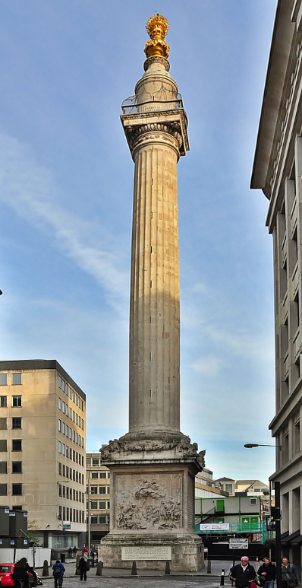
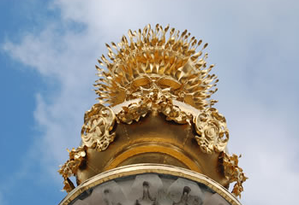
The Monument – London
- The Monument stands at the junction of Monument Street and Fish Street Hill in the City of London.
- It was built between 1671 and 1677 to commemorate the Great Fire of London and to celebrate the rebuilding of the City.
- As part of the rebuilding, Sir Christopher Wren (the architect of St. Paul’s Cathedral) and his friend, Dr Robert Hooke, provided a designed The Monument.
- On the top of The Monument there are flames to represent the Great Fire.
- The Monument, is 61 metres high (202 feet) because that is the exact distance between it and the site in Pudding Lane where the fire began.

