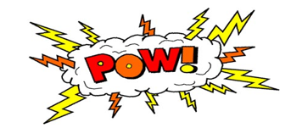Year 2 Topic

Lesson 2

You are going to use all the fantastic information that you have learned about the Great Fire of London over the past few months to complete one (or more if you would like!) of the following activities:

**Develop your creativity:**

* Create a design for housing and buildings in New London
* Make a map
* Create a model
* Design a new sign or LOGO
* Create a guide to your New London

