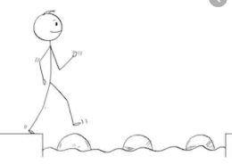
Year 2 Writing
Lesson 1 Steppingstone activity
Monday 23rd March 2020
LO: To create expanded noun phrases
Success Criteria:
- Look at the picture
- Choose a noun
- Choose an adjective to describe the noun (or come up with your own!)
Task (with links):
Watch the clip https://www.literacyshed.com/onceinalifetime.html
Look at the pictures you have been given.
Write a sentence for each one. Remember your capital letter and full stop!
You can use the word bank to help you.
What
like?
EG: The big turtle.

Word bank:
Adjectives | Nouns
big  green  brown  old  red  huge  slow | man  sky  turtle  boat  E.g.  The big turtle.

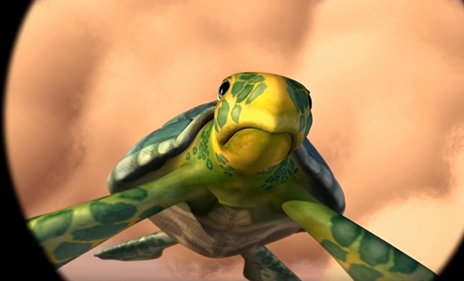
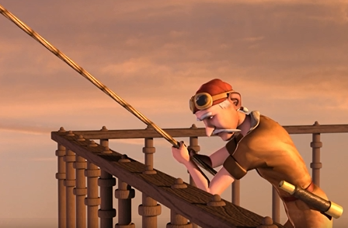

Year 2 Writing
Lesson 1
Monday 23rd March 2020
LO: To create descriptive sentences
Task (with links):
Watch the clip https://www.literacyshed.com/onceinalifetime.html
Look at the pictures you have been given.
Create a descriptive sentence for each one, including nouns, verbs and adjectives. You can use the word bank to help you.

Success Criteria:
- Look at the picture
- Choose a noun or create your own
- Choose one or more adjectives or create your own
- Choose a verb or create your own
- Create your sentence. Make sure you read it back to check it makes sense!

Challenge: Include adverbs in your writing.
Word bank:
Adjectives | Nouns | Verbs | Adverbs
old, wrinkly  tired, bored,  huge, bright  enormous, friendly | man  sky  turtle  boat | glided, flew  looked, stared  threw, travelled  caught, landed | slowly  gently  carefully  quickly
E.g. The tired, old man stared at the bright green turtle as it gently glided over him.
