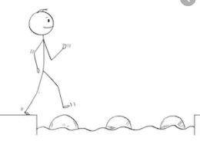
Year 2 Writing
Lesson 1 Steppingstone activity
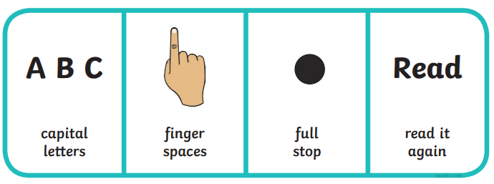
Monday 30th March 2020
LO: To use capital letters and full stops

- the cat sat on the red mat
- my toy is green and black
- i want to play with you
- the hat is big and soft
Success Criteria:
- Read the sentences.
- Write the sentences using a capital letter and full stop.
- Underline your capital letters and full stops.

Challenge: Make up your own sentences for the pictures below
Remember your capital letters and full stops!
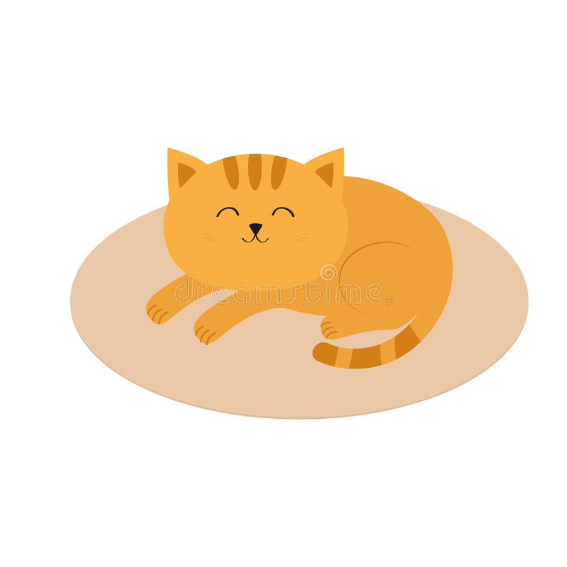

Year 2 Writing
Lesson 1
Monday 30th March 2020
SPAG
LO: To use different types of sentences
Success Criteria:
- Read the sentences out loud
- Decide- Is this a command (!) or question (?) Write C for command or Q for question (the first one is done for you)
- Then finish the sentences with the correct punctuation – Remember ! or . for a command and ? for a question

Look at the page below for the ‘Questions and Commands’ poster!
Command or question:
- Tidy your room! ___ C____
- Would you like some cheese? ________
- Which way is it to the shop? ________
- Get me some new socks! ________
- Is this a command? ________
- Check your work carefully. ________
- Stand on your head. ________
Finish the sentences using the correct punctuation: ? ! or .
- Go back in to the classroom ___
- Finish your dinner and go out to play ___
- How high will your kite fly ___
- Meet us at five o’clock ___
- Is Paris the capital of France ___
- Stop fighting ___
Challenge: Make up and write one of your own questions and one of your own commands
EG: Do you know the way to the park?
I feel so happy today!

