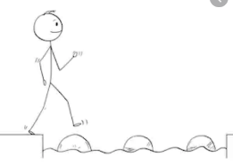
Year 3 Maths
Steppingstone activity
Lesson 6
LO: To use Base 10 jottings for addition with and without exchanges
Success Criteria:
- Write the number sentence (e.g. 23 + 18 =)
- Represent the numbers as tens and ones using Base 10 jottings
- Count the tens first, crossing off as you do
- Count the ones, continuing from your last ten (e.g. 10, 20, 30 then 31, 32…)
- Write the answer to complete your number sentence

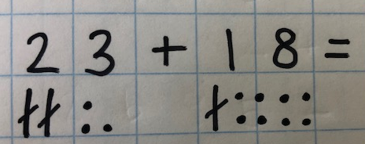
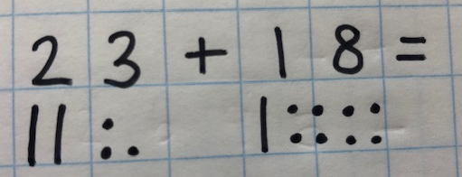
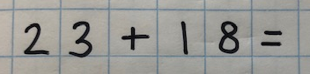
Model:
1.
3.
2.

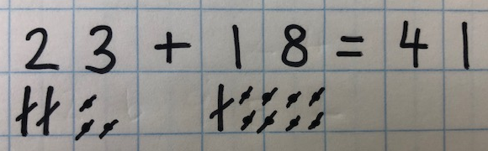
5.
4.

Year 3 Maths
Lesson 6
LO: To use column addition with exchanges
Success Criteria:
- Line your numbers up in the place value columns
- Add the ONES, write answer below and any exchanges
- Add the TENS write answer below and any exchanges
- Add the hundreds
Model
362 + 274 =
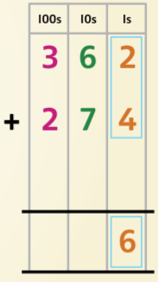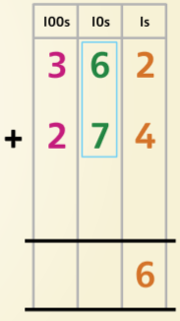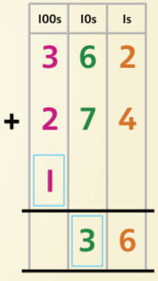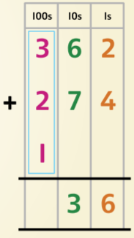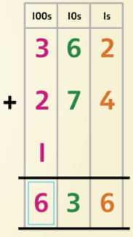
362 + 274 = 636

Year 3 Maths - Main activity
Complete at least 2 columns, more if you can!
Task 1 | Task 2 | Task 3 | Task 4
Practice  Use base ten (deines) jottings to work these out:  a) 24 + 35  b) 13 + 29  c) 25 + 17  d) 33 + 18  e) 48 + 14  f) 27 + 25  g) 14 + 34 | Practice  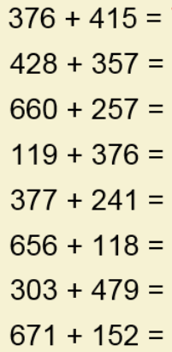  Use column addition to solve these: | Reasoning  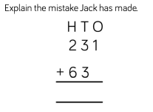  U  Correct it and solve it.  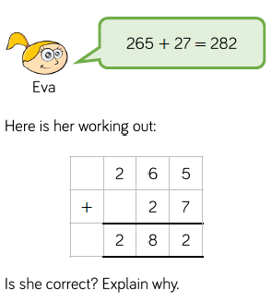 | Problem solving  Sort the additions into the table:  No exchange Exchange 10 ones Exchange 10 tens

