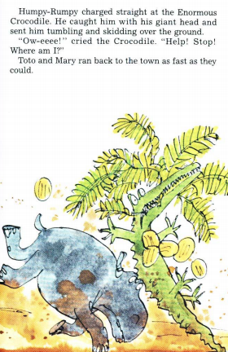
Year 3 Reading
Text: The Enormous Crocodile
If you have the book, make sure you have read up to page 30 to match up with where we are in writing activities.

(Toto and Mary ran back to the town as fast as they could.)
Reading focus: Inference
Summarise the plot so far.
Create a quick story map if it helps, or just think to yourself or tell another person.
Choose a thing that the crocodile did and copy the sentence that tells you what it was from the text. In another colour, explain what that action tells the reader about how the crocodile feels.
Do this 3 times- each time choose a different character and that character’s actions.
Example:
The Enormous Crocodile laughed out loud and disappeared back into the thick jungle.
The crocodile enjoys scaring and annoying other creatures and does not care that they do not like him. He feels happy when other characters are upset.

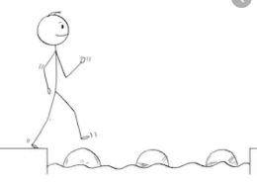
Year 3 Reading
Steppingstone activity
Day 1
Reading Focus: Inference

Text: The Enormous Crocodile
If you have the book, make sure you have read up to page 30 to match up with where we are in writing activities.

(Toto and Mary ran back to the town as fast as they could.)
Copy the picture above and write a sentence to say how Humpy Rumpy feels, and how the Enormous crocodile feels. Use the word because to tell how you know (based on clues from the picture).

