Year 3 Science
Lesson 2
LO: Compare how things move on different surfaces
Example:
Task:
Use a spinning top if you have one, or a coin or another spinning toy if you don’t.
Spin the object a few times to get the knack of it!
Then, choose at least four different textured surfaces (rough, smooth, shiny, bumpy etc.) to spin your object on.
Each time, count or use a timer (e.g. on a phone/tablet) to see how long the object spins for.
Does the surface affect how long it can spin?
Which is best for spinning? Which is worst?
Why do you think this is?
Make a table to show your results

Example:
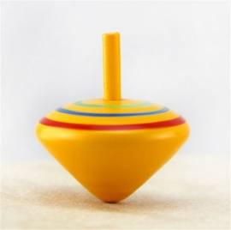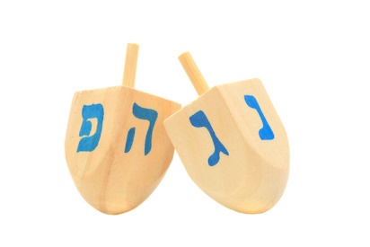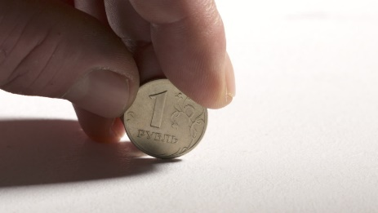
Surface | Length of spinning time
carpet
table
tea towel
sand paper

