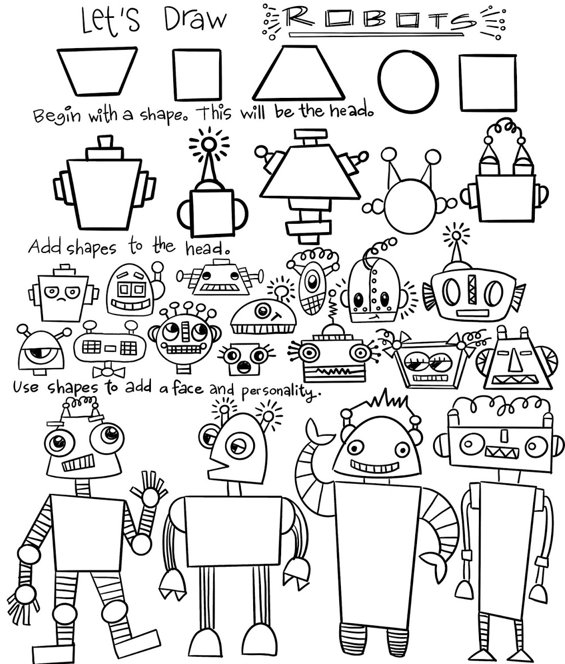
Art - WEEK 1
LO: To draw lines of different sizes and thicknesses

Have a go at designing your own robot! Follow the ideas sheet here to get you started and then go with your imagination – how many buttons does your robot have? What shapes can you include? What can your robot do? Does it have a name and any special powers?

If you would like to have a go at more robot art activities, have a look at Cassie Stephens’ website for more robot-themed art projects:
https://cassiestephens.blogspot.com/2020/03/robot-week-home-based-art-making.html

Once you have finished designing and colouring your robot, can you do some writing about your robot? Here are some ideas to start you off… Or you could think of your own!

1) I found a robot in my bathroom…
2) The day I built a robot and it came to life…
3) I just found out that my parents are robots!
4) My family adopted a robot…

