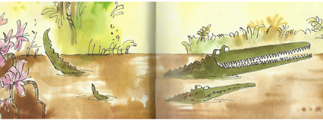
Year 3 Writing
Week 2
Lesson 1
LO: To use and spell words with suffixes
Task:
Read up to end of P 30 (Toto and Mary ran back to the town as fast as they could.)
Answer these questions in your head: What did the Enormous Crocodile do? Who saved the children?
Remind yourself of what a suffix is (an ending added to a root word that slightly alters its meaning).
In Key Stage 1, you learnt spelling rules to add –ing, -ed, -est, -ful as suffixes. You were taught to double a final consonant (bat/batting) or change y to i (beauty/beautiful). You also sometimes need to drop a final vowel (mine+ ed=mined).
Write down three words in the section you read today with –ly suffix.
The Y3 suffixes you are finding today are: -ly, -er, -ous.
Make a table and try to find root words that change when suffixes are added. Remember that not all root words can have all suffixes added.

Success Criteria:
- Say root words softly to yourself to test if they make sense/sound right with different suffixes.
- You can look through the book to try to find words with these suffixes.
- You can look in a dictionary to find words with different suffixes and check spellings.
- Try to think of ways to remember spelling rules.
- If you are not sure if a suffix works with a root word try and say it in a sentence to check if you can understand it used in that way.
E.g.
Root word | -ly | -er | -ous
danger | x | x | dangerous
easy | easily | easier | x
x | x | x | fabulous
Sometimes –ous suffixes do not have an obvious root word so you can include those too.

Extra challenge (optional):
Use some of the words with suffixes that you generated in sentences to practise their spellings and show you understand their meanings in context.
Example: Toto and Mary did not realise that the coconut tree they were going to climb was dangerous because it was the Enormous Crocodile’s trap.

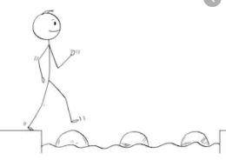
Year 3 Writing
Steppingstone activity
Lesson 1
LO: To spell and use suffixes –ing, -ed, -er
Task:
Share the book with an adult or older sibling up to end of P 30 (Toto and Mary ran back to the town as fast as they could.)
Answer these questions: What did the Enormous Crocodile do? Who saved the children?
A suffix is an ending you add to a root word to slightly change its meaning.
We are going to look at suffixes –ing, -ed, -er.
If you add a suffix you often need to add an extra letter (double the final consonant) or drop a silent e.
Sad+ er = sadder get + ing = getting rub + ed = rubbed hate + ing = hating
Make a table and try to find root words that change when suffixes are added. Remember that not all root words can have all suffixes added.

Success Criteria:
- Choose some simple root words
- Say root words softly to yourself to test if they make sense/sound right with different suffixes.
- Try to think of ways to remember spelling rules.

E.g.
Root word | -ing | -ed | -er
sad | x | x | sadder
rub | rubbing | rubbed | rubber
take | taking | x | taker

Extra challenge (optional):
Write some sentences that use some of your words from the suffix table to show their meanings.
E.g. The Enormous Crocodile was taking coconuts off the ground to make his disguise.

