**Year 4 Reading**

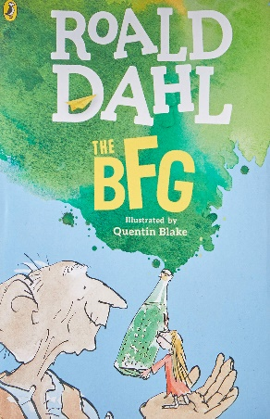**Date: Monday 23rd March 2020  
LO: To summarise key information from a text**

**Task:**

Read the first 2 chapters of the BFG – ‘The witching hour’ and ‘Who?’.

Summarise some key information about the text in bullet points.

Who are the main characters? Describe them.

Where is the story set?

What is the witching hour? What time of day is it?

**

**Steppingstone activity**

**Task:**

Share the first 2 chapters of the BFG with an adult or an older sibling – ‘The witching hour’ and ‘Who?’.

Use the pictures to write some key facts about the main characters