Year 4 Reading
Steppingstone activity
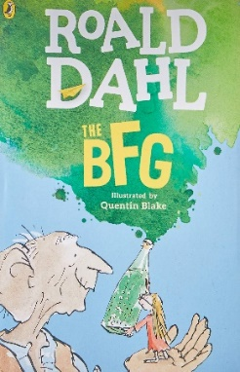
Date: Monday 30th March 2020
LO: To retrieve key information from a text
Task:
Share the next chapter ‘The Giants’, with an adult or older sibling
Inner circle: Retrieve as many key facts as you can about the giants
e.g. There are 9 giants altogether.
They are tremendously tall.

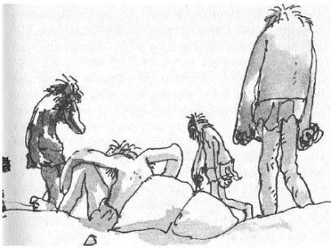
Year 4 Reading
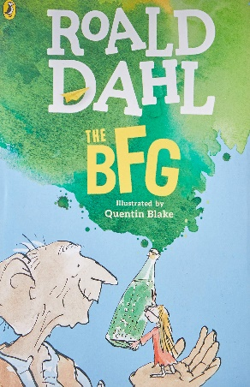
Date: Monday 30th March 2020
LO: To retrieve and infer key information from a text
Task:
Read the chapter ‘The Giants’.
Inner circle: Retrieve as many key facts as you can about the giants
e.g. There are 9 giants altogether.
Outer circle: Infer anything you can about the giants
e.g. They are quite lazy creatures (It says in the text “3 or 4 were sitting quite motionless on the rocks”).

