Week commencing Monday 30th March 2020
LO: To make an instrument
Starter:
Listen to one of your favourite songs and identify the different sounds you can hear.
Create a table and describe what the sounds you hear are like?

Model
What instruments do you hear? | What sound do they make? | How does it make you feel?
Guitar | An electric guitar solo | Excited
Piano | High, cheerful notes | Happy
Drums | A steady, sound beat | Calm
Name of the Song: Ed Sheeran - Thinking out loud

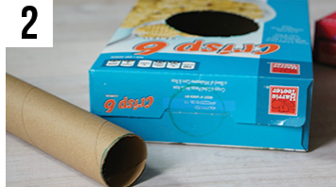
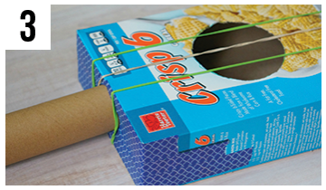
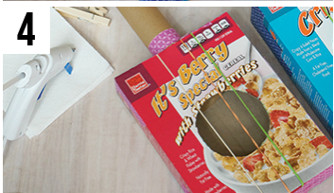
Now you have heard different instruments and their sounds, try making one! Here are example instructions of how to make your own guitar using recyclable items. Try and make your own, or an any other instrument of your creation!
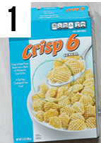
- Find a cereal
Box. Draw a circle in the centre (Use
a tea mug).
Cut out
the circle. 2. Make a circle on the 3. Stretch rubber bands 4. Stick two lollipop sticks
top, cut it out. Insert a around the neck and tape to the box, under the string
toilet roll and tape it. them to the bottom. to make the feats.

