**Year 4 Writing**

**Lesson 1  
LO: To identify word classes**

After being dropped off with his boring, old Grandpa' one boy's dismay is turned into a thrilling adventure through the power of a shared imagination, a 'Radio-Flyer' and a story telling Grandpa. When Dad returns will the fun be over?

We want you to create a word bank of adjectives, nouns and verbs using this video. **Use a thesaurus to help!**

Use the description above to get started.

**Task (with links):**

Watch this video clip: [https://www.literacyshed.com/takingflight.html](https://www.literacyshed.com/takingflight.html)



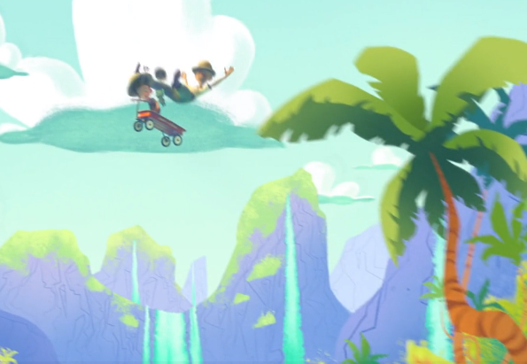

**Success Criteria:**

|  |
| --- |
| 1. **Watch the video** |
| 1. **List the objects you see in the picture (Nouns)** |
| 1. **List the words that describe what you see (Adjectives)** |
| 1. **List the action words (Verbs)** |

**Word bank:**

|  |  |  |
| --- | --- | --- |
| **Adjectives** | **Nouns** | **Verbs** |
| **boring** | **Grandpa** | **dropped** |

**Can you use the words you have collected to make a descriptive sentence?**

**Year 4 Writing**

**Steppingstone activity**

**Lesson 1  
LO: To identify word classes   
Success Criteria:**

**Task (with links):**

Watch this video clip: [https://www.literacyshed.com/takingflight.html](https://www.literacyshed.com/takingflight.html)





|  |
| --- |
| 1. **Look at the picture** |
| 1. **List the objects you see in the picture (Nouns)** |
| 1. **List the words that describe what you see (Adjectives)**   After being dropped off with his boring, old Grandpa' one boy's dismay is turned into a thrilling adventure through the power of a shared imagination, a 'Radio-Flyer' and a story telling Grandpa. When Dad returns will the fun be over?  We want you to create a word bank of adjectives, and nouns using this video. **Use a thesaurus to help!**  Use the description above to get started. |

**Word bank:**

|  |  |
| --- | --- |
| **Adjectives** | **Nouns** |
| **boring** | **Grandpa** |

**Can you use the words you have collected to make an expanded noun phrase?**