Year 4 Writing
Lesson 1
LO: To write descriptive sentences
Task (with links):
Watch this video clip: https://www.literacyshed.com/takingflight.html
Dad's point of view in the story. How does he feel when he sees the two of them so dirty? What goes through his mind to change his mood?
We want you to retell the beginning and ending of the story from Dad’s point of view. Does his mood change? How does he feel?

Success Criteria:
- Watch the video
- Note down what happens at the start
- Note down how Dad feels at the start
- Use your notes to write the beginning
- Note down what happens at the end
- Note down how Dad feels at the end
- Use your notes to write the ending

Word bank:
Fronted Adverbials | Adjectives | Nouns | Verbs
On the way to work,  Early in the morning,  Once I dropped him off,  When I got back, | Sunny, beautiful  Delicious  Soggy, wet  Sad, miserable | Tony  Grandpa  Radio flyer  Car | drove  arrived  dropped  surprised

Feelings
Sad Miserable Confused Upset Confusion Curious Nervous Excited Thrilled
Surprised Astonished

Part of the story | Dad’s feelings
Beginning  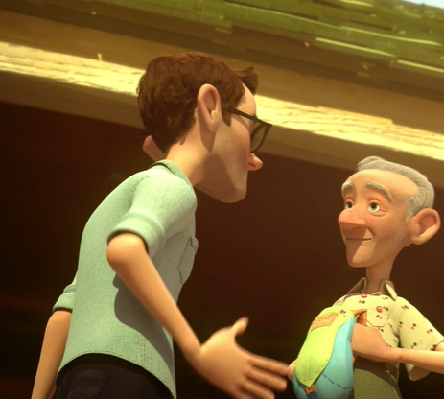  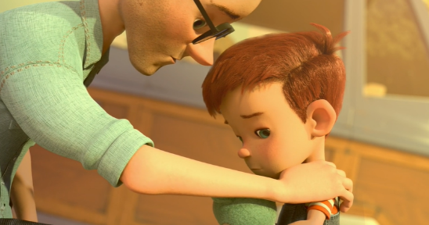  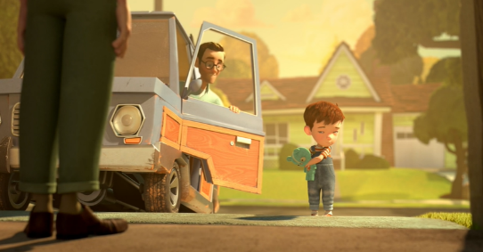 | Key Questions:  Where is Dad going?  What is Dad doing?  How does he feel about leaving Tony?
Model
- I am going to work
- I am dropping Tony off at Grandpa’s
- I feel miserable because I can’t play with Tony.
Model
On my way to work, I have to drop Tony off to his Grandpa’s house. I have to work to provide important and delicious food for my family and to make sure we have a lovely, comfortable house for us to live in. What I really want is to be with Tony and play many exciting, enjoyable games.

Ending  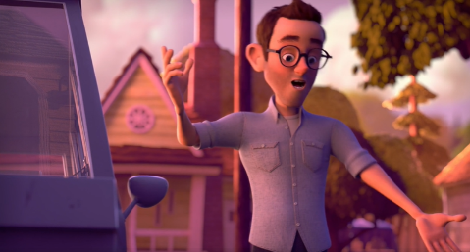  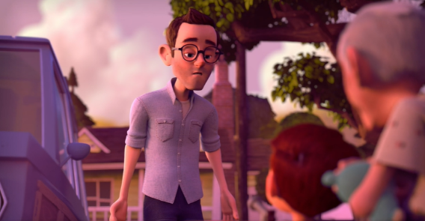  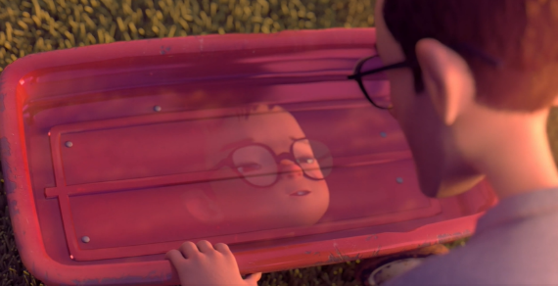  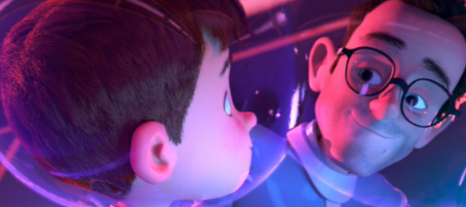 | Key Questions:  Where has Dad been?  What does he remember?  How does he feel about his memories?  What do they do together?
Model
- I am surprised by what Tony and Grandpa have been up to
- I am collecting Tony
- I remember when he was young with Grandpa and all the fun they used to have

Model
When I returned from work, Tony and Dad were covered in water. What a mess! What had they been up to? I was in total confusion. But then, I saw my old, rusty Radio Flyer…

EXTENSION:
Can you answer these questions?
- How have Dad’s feelings changed?
- How does he feel when he sees the two of them so dirty?
- What goes through his mind to change his mood?

Year 4 Writing
Lesson 1
LO: To write descriptive sentences
Task (with links):
Watch this video clip: https://www.literacyshed.com/takingflight.html
Dad's point of view in the story. How does he feel when he sees the two of them so dirty? What goes through his mind to change his mood?
We want you to retell the beginning and ending of the story from Dad’s point of view. Does his mood change? How does he feel?

Success Criteria:
- Watch the video
- Note down what happens at the start
- Note down how Dad feels at the start
- Note down what happens at the end
- Note down how Dad feels at the end

Word bank:
Fronted Adverbials | Adjectives | Nouns | Verbs
On the way to work,  Early in the morning,  Once I dropped him off,  When I got back, | Sunny, beautiful  Delicious  Soggy, wet  Sad, miserable | Tony  Grandpa  Radio flyer  Car | drove  arrived  dropped  surprised

Feelings
Sad Miserable Confused Upset Confusion Curious Nervous Excited Thrilled
Surprised Astonished

Part of the story | Dad’s feelings
Beginning | Key Questions:  Where is Dad going?  What is Dad doing?  How does he feel about leaving Tony?
Model
- I am going to work
- I am dropping Tony off at Grandpa’s
- I feel miserable because I can’t play with Tony.
 | 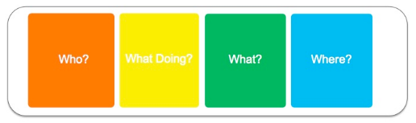

Ending | Key Questions:  Where has Dad been?  What does he remember?  How does he feel about his memories?  What do they do together?
Model
- I am surprised by what Tony and Grandpa have been up to
- I am collecting Tony
- I remember when he was young with Grandpa and all the fun they used to have

