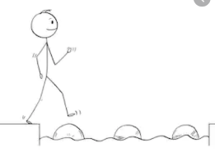
Year 1 Maths
Steppingstone activity
Lesson 1
LO: Add by counting on
Success Criteria:
- Represent and use number bonds and related subtraction facts within 20

Model
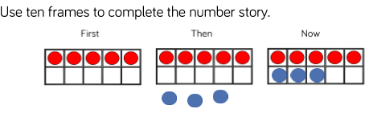
Now you try… draw the counters in the tens frames
First Then Now
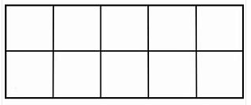
Year 1 Maths
Lesson 2
LO: To use their knowledge of number bonds to 10 to find number bonds to 20
Task:
You are going to practise making number bonds to 20.
Success Criteria:
- work systematically to help find all the possible number bonds to 20

Model:

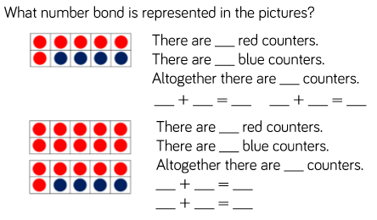

Year 1 Maths
Main activity
Complete at least 2 columns, more if you can.
Task 1 | Task 2
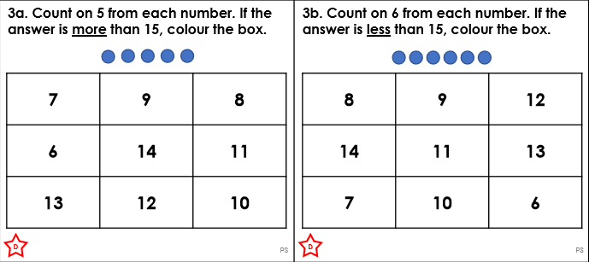 | 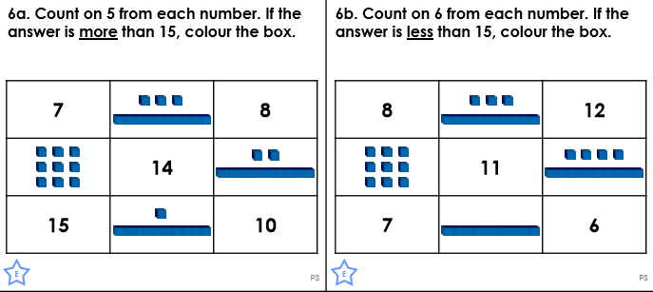
Task 3 | Task 4
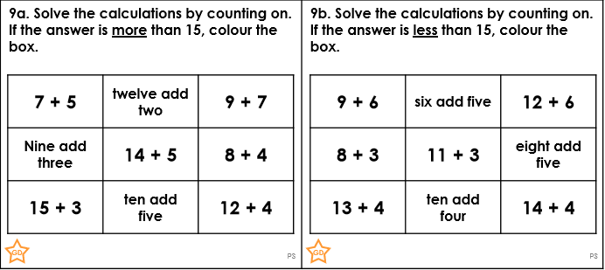 | 