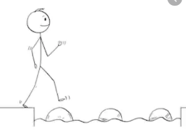
Year 1 Maths
Steppingstone activity
Lesson 1
LO: Add by making 10
Steps to success:
Children add numbers within 20 using their knowledge of number bonds. It is important that children work practically using ten frames and/or number lines to help them see how number bonds to 10 can help them calculate. They will move towards using this as a mental strategy.
- Count the red counters and write how many you have, eg 7.
- Count the blue counters and write how many you have, eg 6.
- Count on from the first number (7) to find out the total number of counters.
- Write the calculation, eg 7 + 6 = 13.
- Look at the tens frame – what do you notice? (You have a full block of 10 and 3 more to make 13).

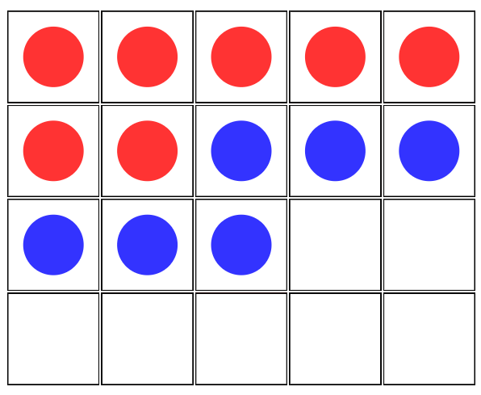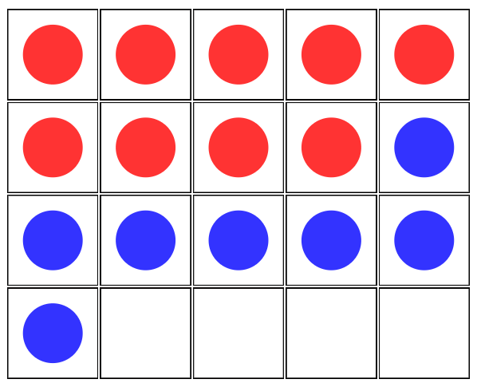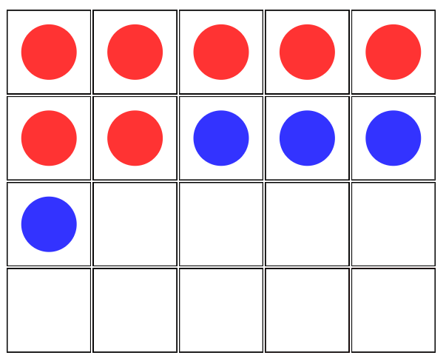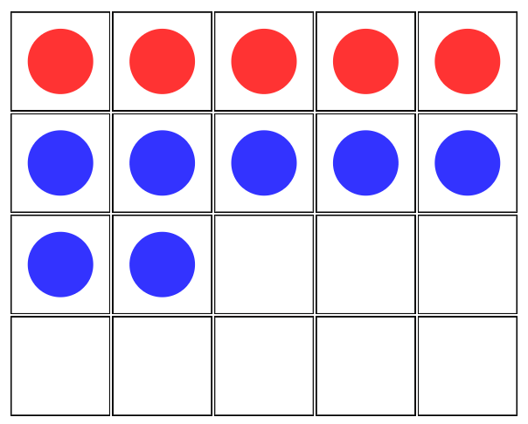
7 + 6 = 13

Lesson 1
LO: Add by making 10
Steps to success:
Children add numbers within 20 using their knowledge of number bonds. It is important that children work practically using ten frames and/or number lines to help them see how number bonds to 10 can help them calculate. They will move towards using this as a mental strategy.
- Make yourself 10 red counters and ten blue counters by drawing, colouring and cutting them out.
- Use the tens frames below to work through the questions in the model.
- If you prefer, use the online resource https://mathsbot.com/manipulatives/tenFrame

Model
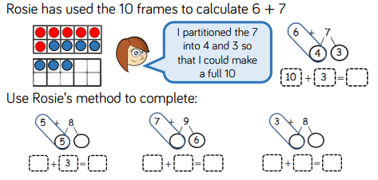

Year 1 Maths
Main activity
Complete at least 2 columns, more if you can.
Task 1 | Task 2
Make your own red and blue counters or use objects to work out:  5+8 = 6+8=  9+4 = your own | 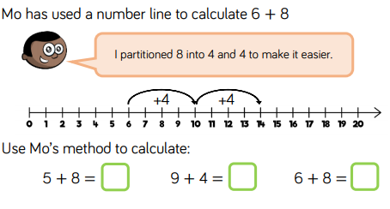  Make up three more of your own.

Task 3 | Task 4
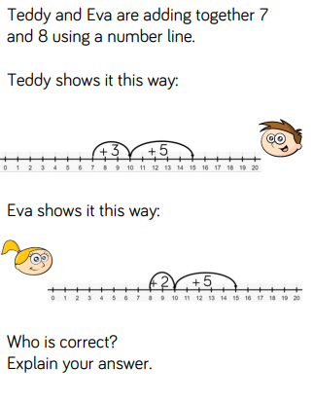 | 