Year 3 Maths
Steppingstone activity
Lesson 1
LO: To know the order and number of days in each month
Success Criteria:
- Get a calendar (a paper one or on a phone)
- Find how many days in each month
- Group the months together which have the same amount of days
- Speak the months out loud so you know what order they go in

Model
Spend time exploring a real calendar at home. Sort the months into groups, by the number of days in each month.
Use the groups to compare - what is the same and what is different?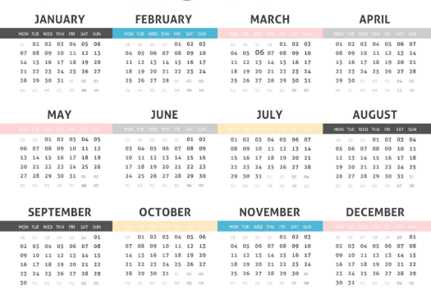

Year 3 Maths
Lesson 1
LO: To number of days in each month, year and leap year.
Success Criteria:
- Get a calendar (a paper one or on a phone)
- Find how many days in each month
- Group the months together which have the same amount of days
- Speak the months out loud so you know what order they go in

Model
Spend time exploring a real calendar at home. Sort the months into groups, by the number of days in each month, this year is a leap year (why is this special?) Use the groups to compare - what is the same and what is different?
Now try: adding up all the days in each month to work out the number of days in this year.
Year 3 Maths
Main activity
Complete at least 2 columns, more if you can!
Task 1 | Task 2 | Task 3 | Task 4
Practice  a) Which month comes before April?  b) Which month comes after June?  c) Which month comes before January?  d) Which month comes 2 months after November?  e) Put these dates in order from earliest to latest:  - 3rd of March  - 2nd of March  - January 31st  - 1st December | Practice  Fill in the missing numbers.  There are _______ days in a year.  There are _______ months in a year.  There are _______ days in a leap year.  There are _______ days in a week.  Leap years happen every _____ years. | Reasoning  Explain your answers.  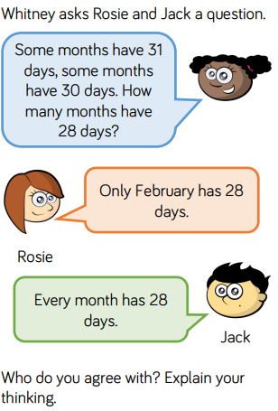  Which card is the odd one out?  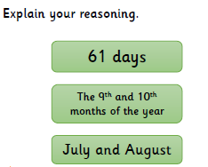 | Problem solving  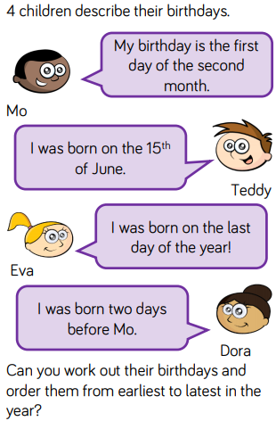  Complete the table about the siblings’ dates of birth using the information below. 