Year 3 Reading
Text: The Enormous Crocodile

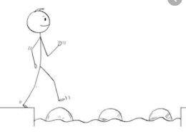
Year 3 Reading
Steppingstone activity
Day 1
LO: To identify descriptive vocabulary used by the author
Success Criteria:
- Read the text
- Draw the crocodiles in the river
- Label your drawing

Year 3 Reading
Date: Day 1
LO: To identify descriptive vocabulary used by the author
Success Criteria:
1. Read the text
2. Draw the crocodiles in the river
3. Label your drawing with adjectives from the text

