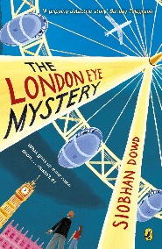
Year 5 Reading
Week 2, Lesson 1
LO: To read for pleasure.
Success Criteria:
- Read chapter 2 of your guided reading book: The London Eye Mystery.
- Write bullet-pointed notes in your exercise book about the key characters and main events that take place.

Example
- Aunt Gloria is Ted’s mum’s sister who is known for upsetting people.
- Aunt Gloria sent a letter to Ted’s house.
- Ted ate Shreddies for his breakfast.

