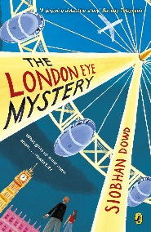
Year 5 Reading
Week 2, Lesson 2
LO: To summarise across more than one paragraph.
Activity: Write a diary entry in role of Ted about your morning.
Success Criteria:
- Skim read chapter 2.
- Read back over your notes from yesterday.
- Use your notes and the text to write a diary entry about the morning, in role as Ted.
Example sentence starters:
- Dear diary, today begun as it usually does with…
- I collected the letters from the doormat and…
- Unimpressed, mum received a letter from our school about Kat who had…
- Mum then open another letter from her sister Gloria, it said that her and her son…

