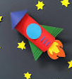
Year 1 working scientifically
The Rocket experiment
Week beginning 29 June 2020
Success Criteria:
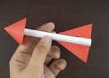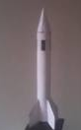
- Use the resources below to make a “straw paper rocket” and a “stomp rocket”.
- Compare how far/high/fast each of them travels.
- Try to measure this in your own way.
- Talk about how you think each rocket works.
- Give your own reasons for how each one works.
Try and draw a picture to explain your findings
You will need:
Paper, card
Straws (paper or plastic)
Plastic bottle
Scissors
Masking or duct tape, normal sellotape too (for rocket)
Plastic tubing
You may decorate your rocket if you wish
Instructions:
- Click on link for the instruct ions on how to make a rocket (straw paper rocket)
https://www.youtube.com/watch?v=0hThMoHB88w

- Once your rocket is ready to fly, place it onto your straw and blow air into it. How far did your rocket go? Feel free to try again. Experiment with the amount of air, angle of the straw or even a whole new rocket design.
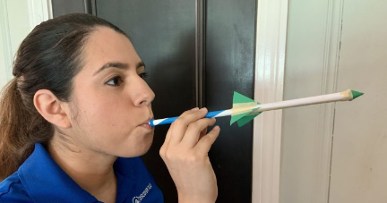

- The stomp rocket Follow the same procedure listed above to make a new rocket. This time, your rocket can be bigger. Try using a full piece of paper for your rocket body. Use the plastic tubing as your size model for the rocket body instead of the straw. Again, we want a tight fit around the tubing. The tubing can be different sizes as long as you can tape it tightly to the bottle to create an air seal.

- To make your stomp rocket launcher, take the bottle cap off the bottle and tape one end of the plastic tubing to your bottle. We highly recommend using duct tape for this part to make a sturdier connection. Make sure your tubing is taped securely onto the bottle.

- Give yourself plenty of space or go outside to launch your rocket. Put your rocket on the open end of the tubing, take aim and stomp on the bottle to launch your rocket. If possible, have a partner aim your rocket so you can focus on stomping.
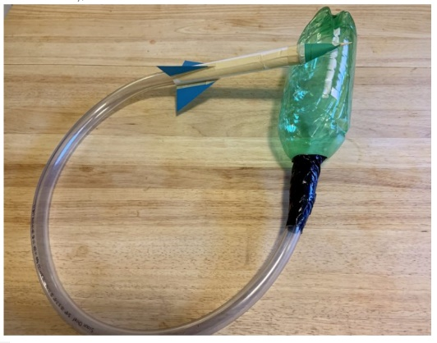
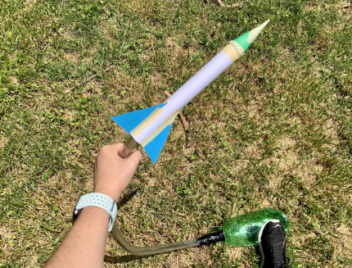

Key Vocabulary:
observe distance travel force

Big Questions:

What do you think will happen?
How does it travel?
How far/fast did it travel?
What will happen when you change the rocket or launcher?
How can you make your rocket travel further or higher?

Experiment with amount of air and the angle of the straw or the length of the tubing or stomping force.
Try placing targets at different distances or heights from your launching site and make your rocket launching into a competition!

What did you find out?
What happened and why?

___________________________________________________________________________________________________________________________

