Year 5 Topic – WWII
Lesson 1
LO: To assess what we already know about WWII.

What do we know about WWII?
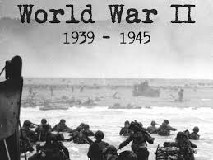

Our exciting new topic for the Summer term is World War II, It is different to other History topic you have studied as it is not about a civilization like the Ancient Egyptians, Anglo-Saxons, Romans etc – it is a period in History, and actually quite a short one! Only 6 years. Nevertheless, WWII had a HUGE impact in a short space of time.
History is about anything that has happened in the past, no matter how recent or distant. WWII is pretty recent history and could definitely be argued as also being modern. Because it is such recent history, people are still alive who experienced it. For this reason, we know a lot about WWII because we have loads of PRIMARY evidence. Secondary evidence comes after the period being studied - we have loads of this as well!

Task (with links):
We would like you to think about what you already know about the topic of World War II and what you would like to find out – do you have any questions you’d like to ask about the War? Are there any ideas you are not sure about?
You can set out this work in any way you like – maybe do thought bubbles, or organise your ideas in a table under the headings e.g. what I know, what I think I know and what I want to find out or you could colour code your thoughts and ideas and use a key - these are just ideas, be creative and get thinking!

