Year 3 Science
Lesson 1
LO: find out how the shapes of solid objects made from some materials can be changed by squashing, bending, twisting and stretching
Task:
Look at your toys and games at home.
Draw and label each of them which involve a force to make them move.
Also, can you find any of your toys which involve squashing and squeezing?
Can you identify which involve non-contact and contact forces?
RECAP: Contact forces are when something touches another object to make it move (including being moved by air).
Non-contact force an object moves without being touched.

Example:
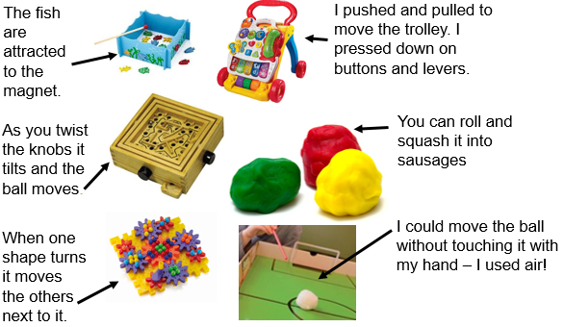

Make your page of drawings and information as colourful and organised as possible!

